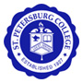
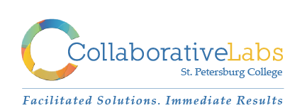
December 15, 2015
Real Time Record

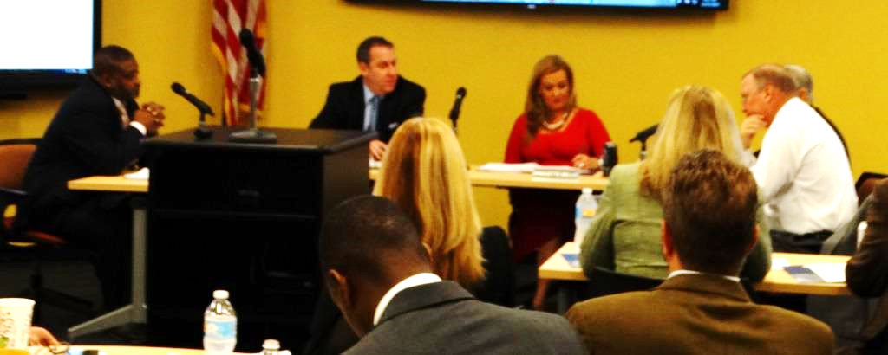

St. Petersburg College
Board of Trustees Annual Retreat

Table of Contents

Executive Summary – Top Considerations for 2016 3
Call to Order 9
Comments 9
Welcome, Objectives and Successes 9
Highlighting SPC’s 2015 Successes 10
The College Experience 11
The Classroom Experience 12
Employee Development 14
Learning Beyond the Classroom 15
Quality Enhancement Plan (QEP) 20
Quality Enhancement Plan Board Discussion 28
The College Experience 30
The College Experience Team Reports 37
The Classroom Experience 39
The Classroom Experience Team Reports 47
Learning Beyond the Classroom 50
Learning Beyond the Classroom Team Reports 55
Employee Development (Deferred) 58
Wrap-Up and Next Steps 59
Artwork 59
Additional Detail about 2015 Successes 60

Executive Summary – Top Considerations for 2016

2015 Successes
- College Experience - examples
  - Improved career services (e.g., processes, physical space)
  - Achieved the 20,000th learning plan
  - Smart Start
- Classroom Experience - examples
  - Imbedded Industry Certifications into the classroom
  - Imbedded the Career Readiness program
  - Consistent books, curriculum, lab topics for Allied Health and Nursing across the campuses
- Beyond the Classroom - examples
  - Participation in Empty Bowls and other community service opportunities
  - Student Exchange Program
- Employee Development - examples
  - Conducted 50,000 hours of professional development training
  - No increases in our health plan
Quality Enhancement Plan (QEP)
- Top two topics being considered: College Readiness for Long-term Success and Strengthening Writing
- We will be honing the topics in January and return to the Board in the spring.
- Board feedback included:
  - Solicit alumni (recent graduates) feedback
  - Connection with instructors is essential for success
  - Employers are looking for students that are equipped with high quality writing skills
  - Readiness is essential
The College Experience
Top Considerations from the Discussion
- Expand use of communication and notification features of MyCourses.
- Each course, including Smart Start, has an assigned math and writing tutor – Expand effort to formalize learning/out-of-class support as an essential component to the College Experience. This should incorporate peep-to-peer tutoring/mentoring.
- Follow-up with those who don’t complete Smart Start and who were successful, as well as those who were not.
- Add online services for all students.
- Personalize the college experience – Communicate proximity to graduation, push career services.
- Merge college experience with academic experience.
- Contextualize lessons according to academic disciplines.

The Classroom Experience
Top Considerations from the Discussion
Courses
- To guide delivery of the major learning outcomes by creating a learning community the classroom that encourages all students’ success.
- An engaging environment conducive to learning.
- Clear expectations (standard syllabus format integrated with calendaring functionality etc.).
- Meaningful and timely feedback (assignments, grades, etc.)… fewer high stakes assessments and more opportunities to be successful.
- Respect and equity.
- Connecting clearly the learning outcomes in the classroom with the program of which the student is enrolled.
- Take advantage of all the resources and tools provided to encourage their success.
Students
- Students take ownership for learning.
- Respectful, prepared, engaged, energetic, and informed. Students ready to perform the best work product that they can produce.
Faculty
- Guide on the Side, not just a sage on the stage.
- Engage in their own professional development to stay current and adjust their pedagogical approach (including culturally relevant pedagogy).
- Commitment from faculty to help them succeed.
- Quality, engaging, energetic instructor with an open mind and able to fairly evaluate works and outputs of students.
- Facilitate out of class learning experience.
- Skilled in LMS.
- Making engaging connections with the students.
- Enthusiasm for teaching and learning.

Learning Beyond the Classroom
Top Considerations from the Discussions
Model
- Impact on the community - $$$$
- Robust enough to support community needs.
- Make model a “benchmark”; make it a part of student expectations.
- Every student should have the opportunity to engage in out of class activities tailored to each campus and academic program.

Opportunity Identification
- Use pathways to identify courses which should include civic engagement or other opportunities.
- Civic engagement fair to let students know what is available.
- Students contribute ideas for service.
- College-wide marketing of available opportunities.

Academic Alignment
- Develop seamless connection between Student Services and Academic Programs.
- How do we balance community and external with the classroom experience (academics)?
- How this helps us move the needle to student success?

Resources
- What is the impact on the College, i.e. costs involved, performance funding, mission to the College?
- Need financial support structure.
- Liability coverage (off-campus, international).

SPC Board of Trustees - Strategic Planning Workshop
St. Petersburg College, Epi Center, 13805 58th Street N. Clearwater, FL 33760
Collaborative Labs (Tropics Lab)
Tuesday, December 15, 2014, 9am – 12pm

Building SPC’s 2016-17 Strategic Direction

Time | Agenda Items | Collaborative Activity
8:45am – 9:00am | Highlighting SPC’s 2015 Successes:  - The College Experience  - The Classroom Experience  - Learning Beyond the Classroom  - Employee Development | Board of Trustee Members, as well as Faculty, Staff and Students will be asked to capture and highlight SPC’s 2015 Successes
9:00am –  9:10am | Call to Order  - Invocation  - Pledge of Allegiance
as needed | Comments  - Public Comment, 286.0114, Florida Statutes
9:10am – 9:20am | Welcome, Objectives and Successes  - Welcome: Chairman Oliver, Trustees, and Dr. Law  - Objectives & SPC’s 2015 Successes: Andrea Henning | Board of Trustee Members and volunteers will highlight SPC’s 2015 Successes
9:20am –  9:50am | Quality Enhancement Plan (QEP)  The session will review recent progress on identifying the potential topics proposed for the College’s QEP, a critical part of the upcoming reaffirmation by the Southern Association of Colleges and Schools (SACS). During the Fall Semester, a series of workshops, forums, and open discussions have been held to develop an appropriate short list of proposed topics to be presented to the Board for its feedback. | Topic 1 (30-min.):  - 20-min. Overview of the QEP process and the short list of proposed topics  - 10-min. BOT discussion
9:50am –  10:20am | The College Experience  This session will provide a summary of the impact of the ongoing 5-part College Experience Project. Particular attention will be given to changes in the orientation component and in the career support and placement activities. Overall impact of the plan will be discussed and next steps in the evaluation and design of the components will be presented.  This session will result in guidance from the Board on areas of emphasis for the College Experience components in the Spring 2016 semester and in the 2016-17 academic year. | Topic 2 (30-min.):  - 5-min. “Just the Facts” Overview  - 20-min. Collaborative Discussion in teams  - 5-min. Team Reports:  Top 5 Considerations for 2016
10:20am –  11:00am | The Classroom Experience  This session will be new in its scope and presentation. The Board will be guided in its review of the experience of students in courses and programs. Rather than focus on support services (as contained in The College Experience), this new focus will begin to build a sharpened focus on the experience of students in the classroom, toward a better understanding of student preparedness, changing student demographics, new technologies available for learning, and the refinement of courses within the recently established Academic Pathways. This session will also identify the kinds of data, information, and metrics desired to support faculty classroom efforts.  This session will result in a renewed focus on the successes and challenges of faculty in the delivery of instruction, toward the goal of identifying appropriate changes in policies, procedures, or allocation of resources. | Topic 3 (40-min.):  - 5-min. “Just the Facts” Overview  - 25-min. Collaborative Discussion in teams  - 10-min. Team Reports:  Top 5 Considerations for 2016
11:00am –  11:30am | Learning Beyond the Classroom  This session will provide an overview of the growing list of opportunities to expand their learning beyond the classroom. Programs that nurture student participation in travel, internships, capstones, civic engagement, and academic competition will be reviewed and detailed. The impact and cost of these initiatives will be presented; additional reporting desired by the Board will be identified.  The outcome of this session will be to identify appropriate changes in policies, procedures, or allocation of resources needed to expand the college’s commitment to Learning Beyond the Classroom. | Topic 4 (30-min.):  - 5-min. “Just the Facts” Overview  - 20-min. Collaborative Discussion in teams  - 5-min. Team Reports:  Top 5 Considerations for 2016

11:30am –  11:50am | Employee Development  This session will bring current the initiatives created in the past several years to enhance the growth, development, training, and preparedness of all employees at St. Petersburg College. Of particular note will be updates on the reclassification of the college’s advisors, the extensive redesign of the annual evaluation of Career Service  Employees, the progress that has occurred in the Faculty Portfolio Project and the overall expansion of training and support initiatives that has now been put in place.  The outcome of this session is to receive feedback from the Board on the fiduciary responsibility of the college to evaluate employees and to strengthen their relevant skills for the improvement of college operations. | Topic 5 (20-min.):  - 10-min. Overview of efforts underway and planned  - 10-min. BOT discussion
11:50am –  12:00pm | Wrap-Up and Next Steps | Dr. Law and the BOT will wrap-up by sharing highlights and next steps.

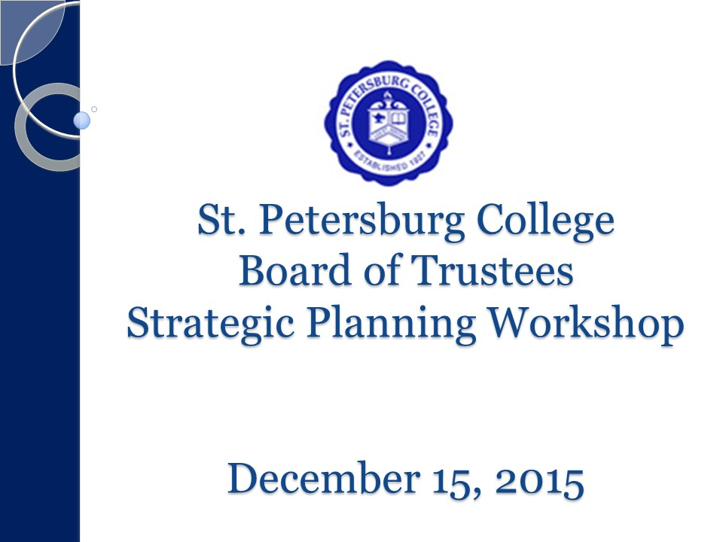
9:00am –  9:10am | Call to Order  - Invocation  - Pledge of Allegiance
as needed | Comments  - Public Comment, 286.0114, Florida Statutes

Chairman Oliver opened the meeting at 9:01am.
Chairman Oliver: Good morning. Let’s open with the invocation and the pledge of allegiance. Mr. Fine led the invocation.

No public comment

9:10am – 9:20am | Welcome, Objectives and Successes  - Welcome: Chairman Oliver, Trustees, and Dr. Law  - Objectives & SPC’s 2015 Successes: Andrea Henning | Board of Trustee Members and volunteers will highlight SPC’s 2015 Successes

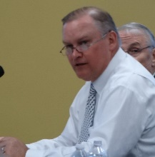
Chairman Oliver: This is our strategic planning workshop, closing out 2015 and kicking off 2016. Dr. Law?
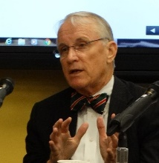
Dr. Law: We’ll show the video about our graduates a little later on. We had two graduation ceremonies. In the morning, we had 356 grads and 310 in the afternoon. To recognize the milestone of our 150,000th graduate, we had six graduates in the video and in the ceremonies three were in the morning, three in the afternoon. The students loved it. It brought great credit to the organization.

Your guidance today will help us set a course going forward next year. We will glean strategic goals from these discussions, and will bring them back to you in January. The budget process will be based on them. I don’t see significant resources on the table. I don’t know where additional resources will come from. There will not be enough to fund two big initiatives: The Call Center and addressing the concealed carry issue. We’ll have to have an organizational response to the concealed carry issue. That will allow us to have armed employees and staff as well. That could be a $1M or more to cover seven locations, 18-20 hours a day. We’ll bring you all of the options. I intend on spending time in January in Tallahassee. I’ll try to get a sense of where we are.

The Board has told us to stay on the mission. We’ve identified five key issues that we will discuss today.

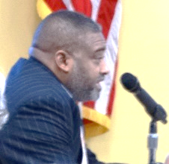
Mr. Gibbons: I want to go back to graduation. We need to take very seriously that Trustees go to the graduation ceremony. We need to make that a priority. I would also like to talk about a Board evaluation. The administration needs to evaluate us on what we’ve done to serve the customers – faculty, students and staff.

Chairman Oliver: Noted.

Dr. Law: The QEP (Quality Enhancement Plan) is part of the accreditation process. We are starting all the activities that lead us to our next accreditation in 2018. There are three parts of the activity. This is guided by performance funding. One is the College Experience. We’re proud of it and we want to renew our focus. Second, we want to mirror that in what we want to call the Classroom Experience. We have to see a different level of throughput. What’s working and not working. How do we engage students? The third part is Learning Beyond the Classroom. Where can we take what happens in the classroom into the community? We want to simply close with a picture. We have four major initiatives in Employee Development. It doesn’t happen without considerable effort. I want you to have a sense of the things that are commandeering our attention in the coming months.

Those are the five areas where we think we’ll be spending our time.

Chairman Oliver: That’s a great overview. Any other comments from the Board? (There were none). I look forward to this every year. We come out with some pretty good plans for the following year that have resulted in improvement for our students.

Andrea Henning, Executive Director, Collaborative Labs: This will be a great morning for strategic planning for 2016. First, let’s claim victory. I’d like to invite faculty and staff to talk about key successes in 2015.

8:45am – 9:00am | Highlighting SPC’s 2015 Successes:  - The College Experience  - The Classroom Experience  - Learning Beyond the Classroom  - Employee Development | Board of Trustee Members, as well as Faculty, Staff and Students will be asked to capture and highlight SPC’s 2015 Successes

The College Experience

The College Experience
- Smart Start completed. For ALL new students.
- Strengthened Career Services Start Smart AND Finish Strong (Revised Centers & Services.)
- Over 20,000 Student Learning Plans
- Implemented the advising model.
- Program-specific orientations.
- Create co-horts with project groups & study groups.
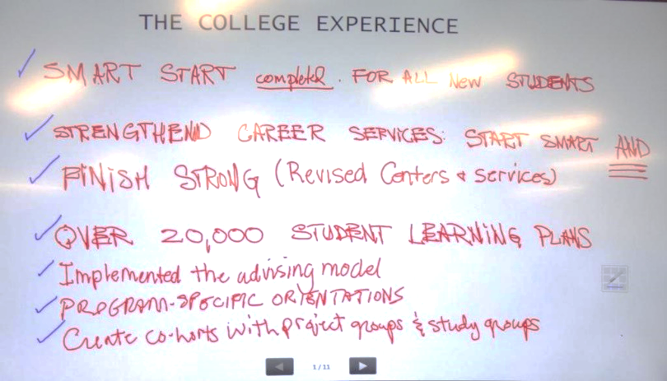

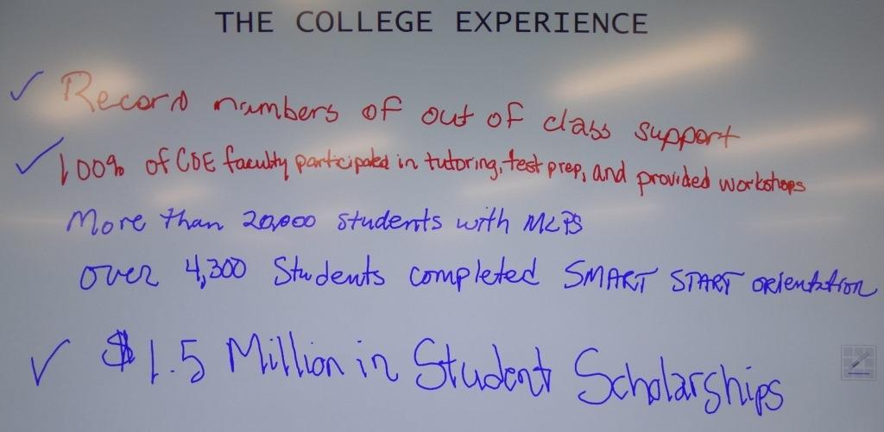
The College Experience
- Record numbers of out-of-classroom support.
- 100% of COE faculty participated in tutoring, test prep, and provided workshops.
- More than 20,000 students with MLPs.
- Over 4,300 students completed Smart Start orientation.
- $1.5M in student scholarships.

Dr. Tonjua Williams, SVP, Student Services: We’ve had a great term so far. We made commitments that we would improve career services. We’ve retrofitted some areas. If you haven’t been to Tarpon Springs, you are missing out. We have achieved the 20K Learning Plan benchmark. We have done a great job with Smart Start. You will be pleased to see some of the data from that.

The Classroom Experience

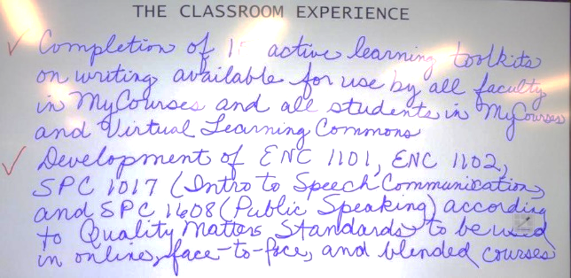
The Classroom Experience
- Completion of 15 active learning toolkits on writing available for use by all faculty in MyCourses and all students in MyCourses and Virtual Learning Commons.
- Development of ENC1101, ENC1102, SPC1017 (Intro to Speech Communications) and SPC1608 (Public Speaking) according to Quality Matters Standards to be used in online face-to-face and blended courses.

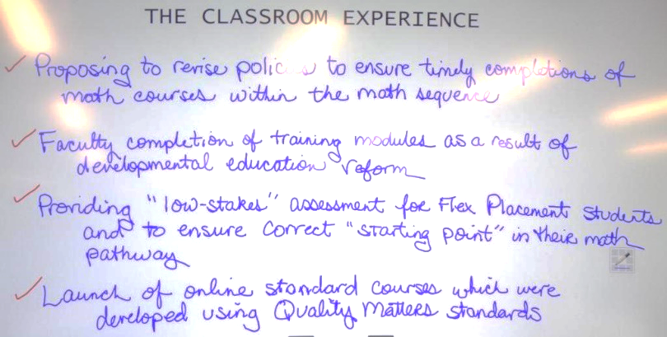
The Classroom Experience
- Proposing to revise policies to ensure timely completions of math courses within the math sequence.
- Faculty completion of training modules as a result of developmental education reform.
- Providing “low-stakes” assessment for Flex Placement students and to ensure correct “starting point’ in their math pathway.
- Launch of online standard courses which were developed using Quality Matters Standards.

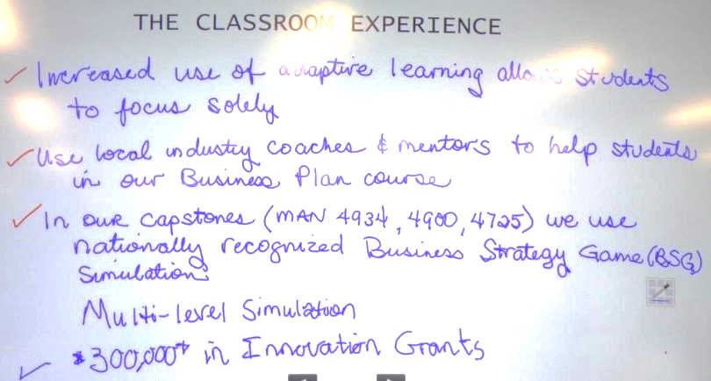
The Classroom Experience
- Increased use of adaptive learning allows students to focus solely.
- Use local industry coaches & mentors to help students in our Business Plan course.
- In our capstones (MAN4934, 4900, 4725) we use nationally recognized Business Strategy Game (BSG) simulations.
- Multi-level simulation
- $300,000 in Innovation Grants.

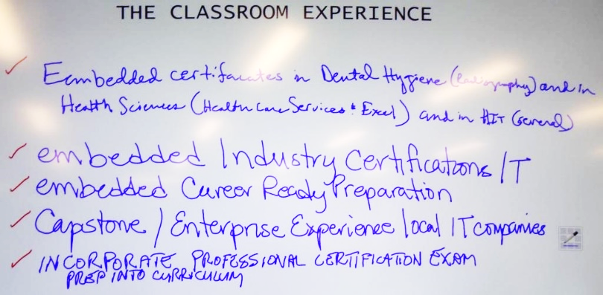
The Classroom Experience
- Embedded certifications in Dental Hygiene (Radiography) and in Health Sciences (Health Care Services & Excel) and in HIT (General).
- Embedded industry certifications IT
- Embedded Career Ready Preparation.
- Capstone/Enterprise Experience local IT companies.
- Incorporate Professional certification exam prep into curriculum.

The Classroom Experience
- Adaptive quizzing in ADN.
- Interactive roundabouts (Nursing)
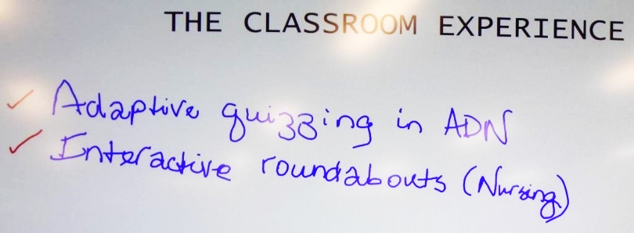

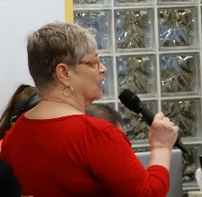
Dr. Sharon Setterlind, Dean, College of Computer and Information Technology: We have two projects that we are working on in the classroom. The first is the industry certification. We have embedded resources, practice exams – it’s proving to be very successful. We have embedded a career readiness preparedness program. Formerly, students weren’t ready for internships. We have embedded nine webinars that teach students how to look for, apply for and interview for jobs.
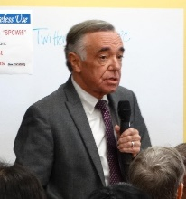
Dr. John Chapin, Dean, Natural Science: We have a series of courses for Allied Health and Nursing. We have several thousand students that take these courses. Across the campuses, beginning this semester, we will have consistent books, curriculum, and lab topics across the campuses. This is the fifth college I’ve worked in and I’ve never seen this before.
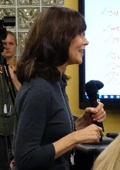
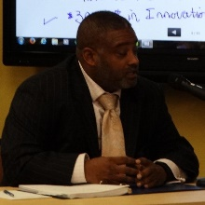
Ms. Frances Neu, VP, Institutional Advancement & Executive Director Foundation: A lot of the work of the Foundation touches on these areas. We awarded over $1.5M in traditional school scholarships and over $500M in presidential scholarships. Also, we held the Steve Wosniak event.

Mr. Gibbons: We talked about focusing on the students making sure their experience is the same for every student. When I go to every campus, I see the same experience and they have the same range of services. I’m very proud of that. No matter what dilemma they have, we have something to help them.
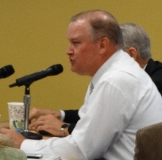
Chairman Oliver: When we talk about the mission, we all do that in different ways. I try to break things down into their simplest parts. First of all, we get them in. and then you get them prepared – the College Experience, the Smart Start – getting them prepared. Third, get them a job or a career – through a degree or certification or whatever means. The common curriculum – that’s simplified. When kids are trying to buy books and they are all different by campus, that’s confusing. The more simplification we can do, the more successful we can be in the end. Get them in, getting them prepared, getting them out and getting them a job.

Andrea: Simple is great.

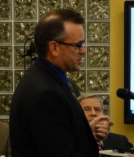
Dr. Jesse Coraggio, VP, Institutional Effectiveness and Academic Services: I wanted to share some quick success rates. We were noticing a slight decline and we’ve turned the trend. We’ve made about half back. College enrollment is up overall 2.2%. Developmental enrollment is up 5.6%, Gateway courses are up 8.8%. African-American males enrolled in developmental courses is up 13.6%. We are still dealing with legislation, but we are in the upward motion.

Andrea: Let’s claim some small victories!

Employee Development

Employee Development
- Faculty Evaluation Digital Portfolio – 1500 faculty users.
- Leadership SPC & SPC Delta Academy.
- 118 Career and Academic Advisors Re-classified from career service to Admin & Professional.
- Approximately 50,000 employee training hours.
- Career Service annual evaluation re-design.
- Center for Excellence in Teaching and Learning (CETL) cohorts.
- Innovation Grants.
- Career staff bi-training.
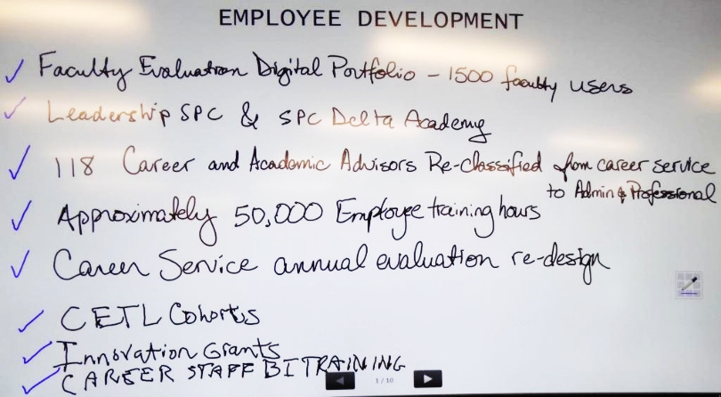

Employee Development
- 876 faculty completed 17,520 hours Quality Matters training.
- 1,062 hours completed of technology and pedagogy training by faculty.
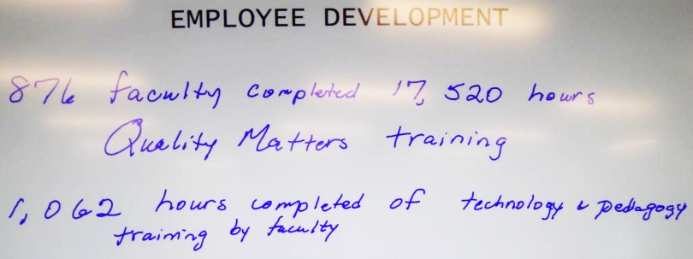
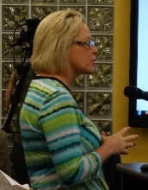
Ms. Desiree Woroner, HR Director of Operations: We delivered over 50K hours of professional development training. We have a faculty portfolio and training on that usage. Revamping of our advisors to be more professional. CETL, organization design. We had a salary increase this year. We had no increases to our health plan.

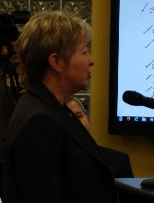
Dr. Susan Colaric, AVP, Online Learning and Services: We have focused on faculty development. We had 17,520 hours that faculty have completed various workshops to get us to Quality Matters standards. We had 1,062 hours completed in technology and pedagogy training.

Learning Beyond the Classroom

Learning Beyond the Classroom
- Volunteer and observations by American Sign Language students.
- Governmental internships for policy students.
- Ethics in Action sponsor diversity & arts workshop.
- Model UN & Model Legislature.
- Student tutors & mentors in Pinellas Co. Schools.
- Student coordinated pro bono legal fair.
- Inter-professional activities and case studies with UF in health programs.
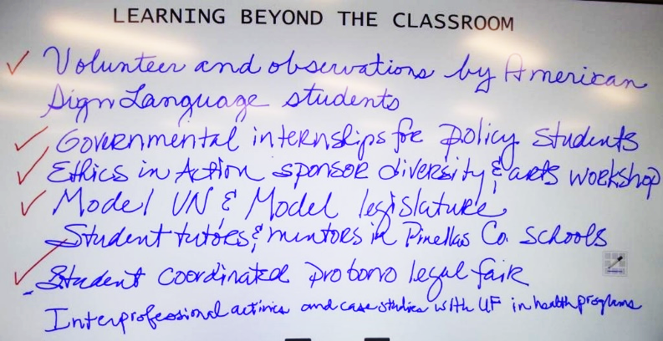

Learning Beyond the Classroom
- PTA students participated in professional volunteer activities.
- Vet Tech international programs in Denmark, Costa Rica, Australia, and Thailand.
- Learning abroad in Jamaica & South Africa for Dental Hygiene & Health Sciences, respectively.
- Showcase event to share projects & research in health sciences – attended by mentors, advisory committee members & new students.
- Over 500 hours of service to local animal rescue organizations – Vet Tech Students.
- Required internships local IT companies.
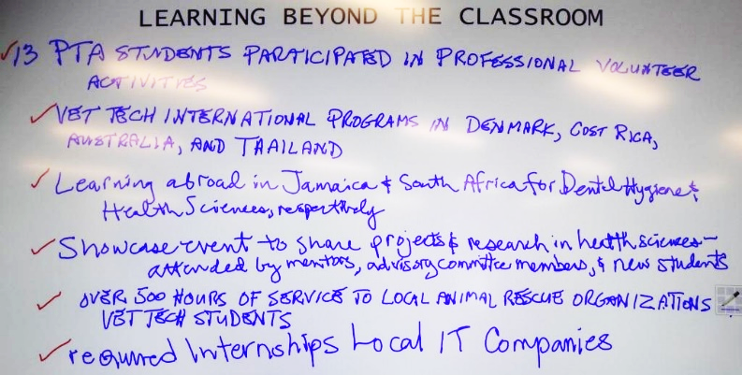

Learning Beyond the Classroom
- Exploratory Lab – onboarding local companies.
- Internships at UF Veterinary Teaching Hospital.
- Student Government.
- STEM (Science, Technology, Engineering, Arts & Math) students at DT led a mini-catapult competition which involved community members & K-12 students.
- MGF1107 students at Clearwater campus visited the M.C. Escher exhibit at Dali to explore math in art.
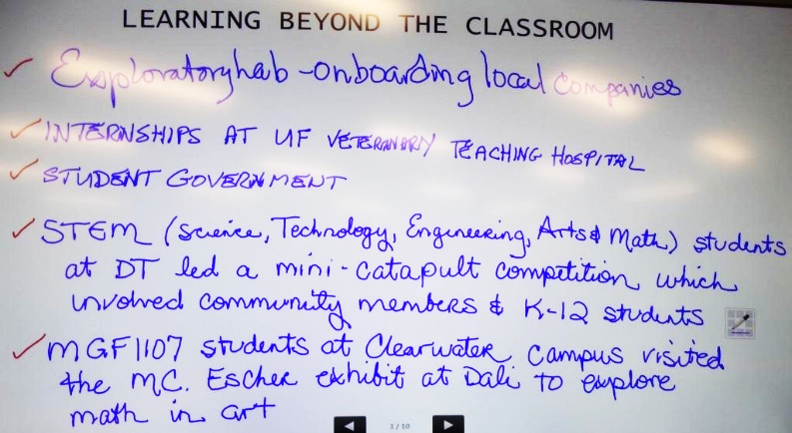

Learning Beyond the Classroom
- Study abroad trip to Greece involved Elementary Statistics class studying the subject through data collection and research.
- 330 students participated in concerts, shows, recitals in the fall. 39 Art events.
- 4 professional development sessions for students pursuing careers in arts & entertainment. 37 students participated.
- Working Artist event at Palladium. 202 participated.
- Ceramics “Empty Bowl” project with St. Pete Free Clinic.
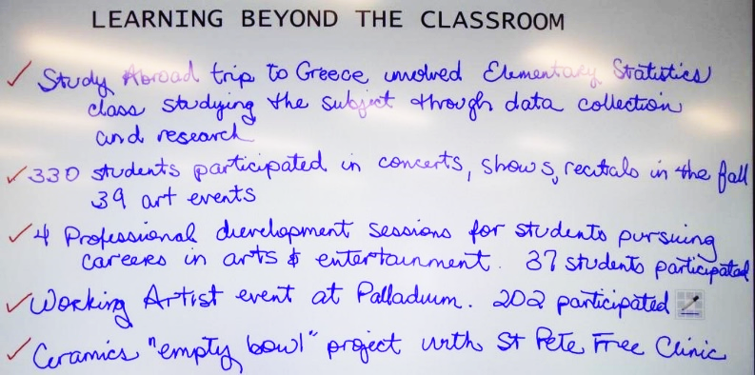

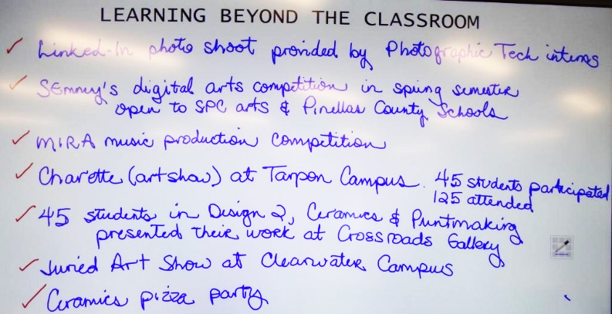
Learning Beyond the Classroom
- Linked In photo shoot provided by Photographic Tech interns.
- SEmmey’s digital arts competition in spring semester open to SPC arts & Pinellas County Schools.
- Charrette (art show) at Tarpon campus. 45 students participated, 125 attended.
- 45 students in Design 2, Ceramics & Printmaking presented their work at Crossroads Gallery.
- Juried Art Show at Clearwater campus.
- Ceramics pizza party.

Learning Beyond the Classroom
- Practica, internships, trip to Jamaica.
- BSN student practicum in Colombia.
- Tarpon Springs aquarium – 10 students self-funded.
- Multiple presentations involving the community (genetically modified foods, birds of prey, climate change).
- Partnering with City of Clearwater for community clean-ups.
- Field trips with Biotech students (diabetes, cell therapies, microbiomes).
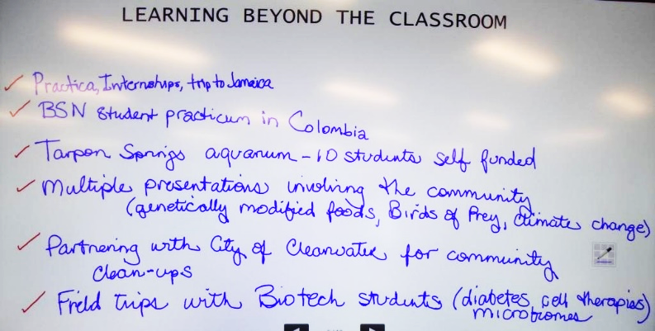

Learning Beyond the Classroom
- Student-led Life Sciences Colloquium.
- Tri Beta National Biology Honor Society field trips (TreeUmph, fossils in Hillsborough River, etc.)
- Various undergrad research projects.
- Participation in the Florida Branch of American Society for Microbiology.
- Field Biology class visits a variety of state parks & volunteer with Tampa Bay Watch.
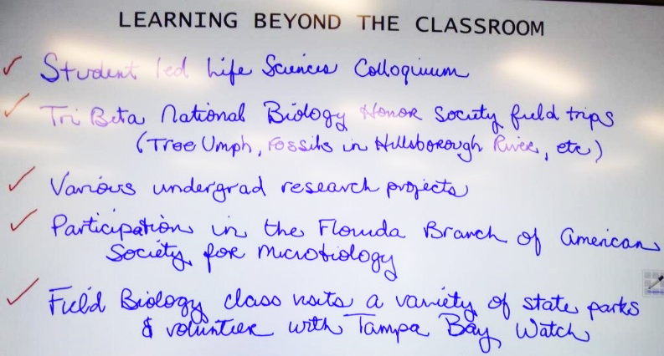

Learning Beyond the Classroom
- Seminole environmental club.
- Microbiology Student Research Assoc Club.
- Medical club at DT/MT (MOSI, Ronald McDonald House)
- A&P students attended cadaver workshop.
- Business Plan & Elevator Pitch Competition.
- Tallahassee Student Leadership trip.
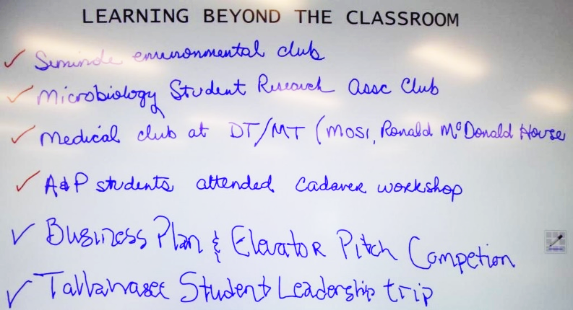

Learning Beyond the Classroom
- Students from DTMT volunteering @ Free Clinic.
- Founda Speakers Event.
- Student engagement thru civic diversity/across disciplines.
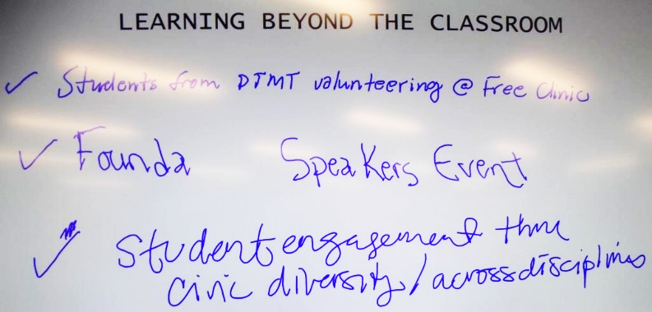

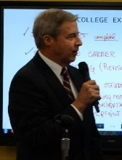
Dr. Jonathan Steele, Dean of Humanities and Fine Arts: Our ceramics students are participating in “Empty Bowls”. This program partners students with people in the community. In April, there will be a Throw-A-Thon. This initiative shows students how to make a positive impact on the community and enhances their retention.

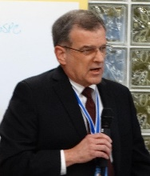
Dr. Rich Flora, Dean, School of Veterinary Technology: Four students went to Denmark on a student exchange program. We sent 24 students to Costa Rica to a sea turtle rehab center. Some students are going to Australia this coming year and in 2017, we are planning for students to go to an elephant rehab center in Thailand.

Andrea: Board members?
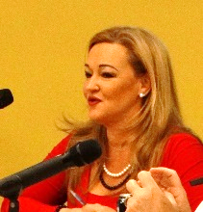
Ms. Bello: Being part of the foundation grants last week was a lot of fun. It’s neat to be a part of that behind the scenes. I wanted to write a check on the spot.

Dr. Law: That happens a lot. When people are part of the scholarship process, there are a lot of tough choices.

There is a great deal to be proud of here. Your guidance has been instrumental. Focus on the mission. The College Experience plan. We had some success and then the legislature dealt us some low cards. You encouraged us to stick with it and now it is turning.

Andrea: Let’s continue to leverage those successes. Let’s hang on to those as we look at 2016.

Note: additional details regarding successes are provided at the end of this document

9:20am –  9:50am | Quality Enhancement Plan (QEP)  The session will review recent progress on identifying the potential topics proposed for the College’s QEP, a critical part of the upcoming reaffirmation by the Southern Association of Colleges and Schools (SACS). During the Fall Semester, a series of workshops, forums, and open discussions have been held to develop an appropriate short list of proposed topics to be presented to the Board for its feedback. | Topic 1 (30-min.):  - 20-min. Overview of the QEP process and the short list of proposed topics  - 10-min. BOT discussion

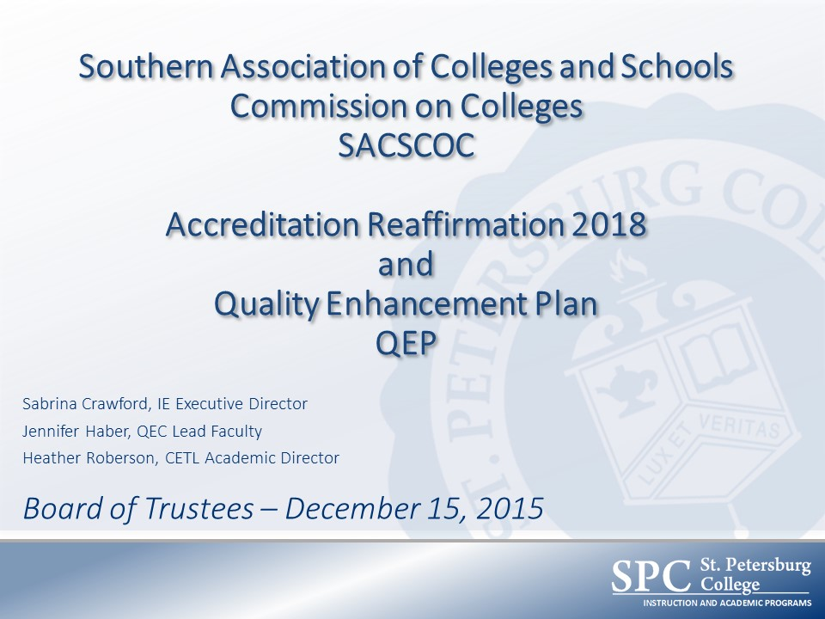

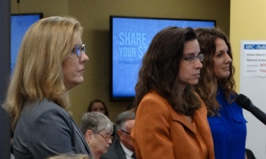
Sabrina Crawford, Executive Director, Institutional Research & Effectiveness: We appreciate being invited to be part of the strategic plan. We came to you in September and gave you an overview of the reaffirmation process. We’ll have the draft this week. We’ll have another overview in January. The report is due for a SACS review in March of 2017. October 10-12, 2017, there will be a site visit. Almost every unit has produced their draft reports.
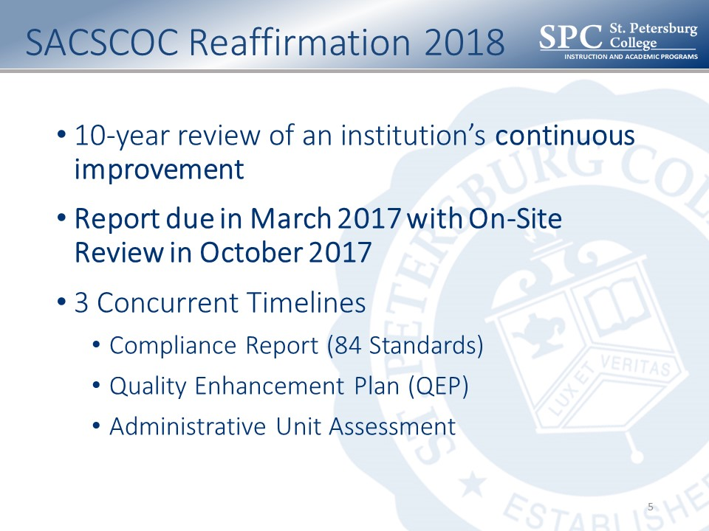

This is a faculty-led initiative. We were told to pick an area that will have a significant impact on student success. The impact report from the last one shows how successful this is. We’ve learned over the course of 10 years that if you hone the topic down and focus on a specific audience, you have better impact. We’ve asked people to share their perspectives and in January, we’ll hone that down to two areas. Then we’ll bring our recommendation to you.

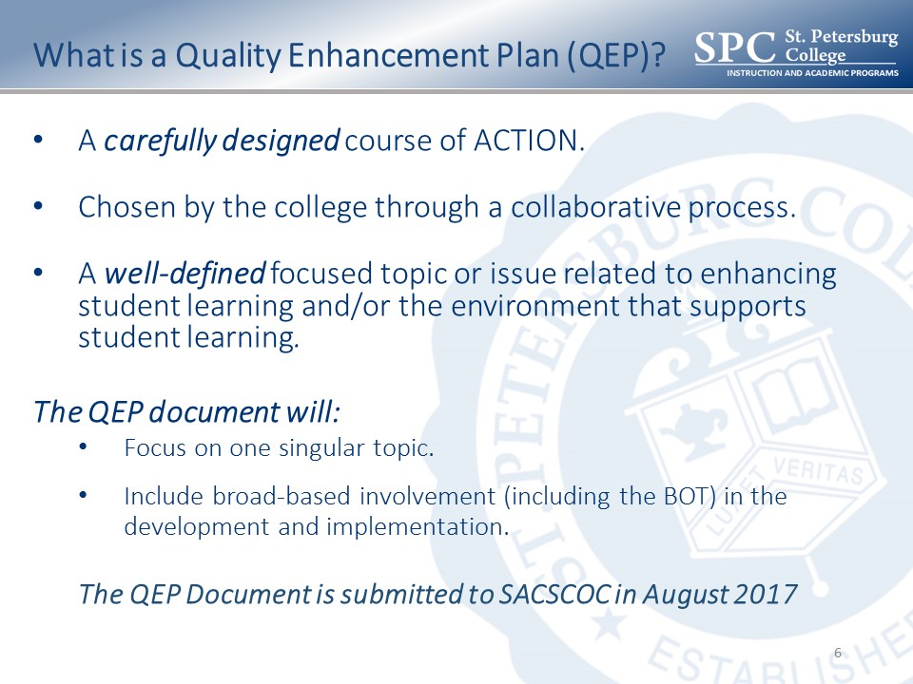

We started looking at topics in August. Had a Collaborative Labs in September. We showed it to constituents and you, then went back out for more information.

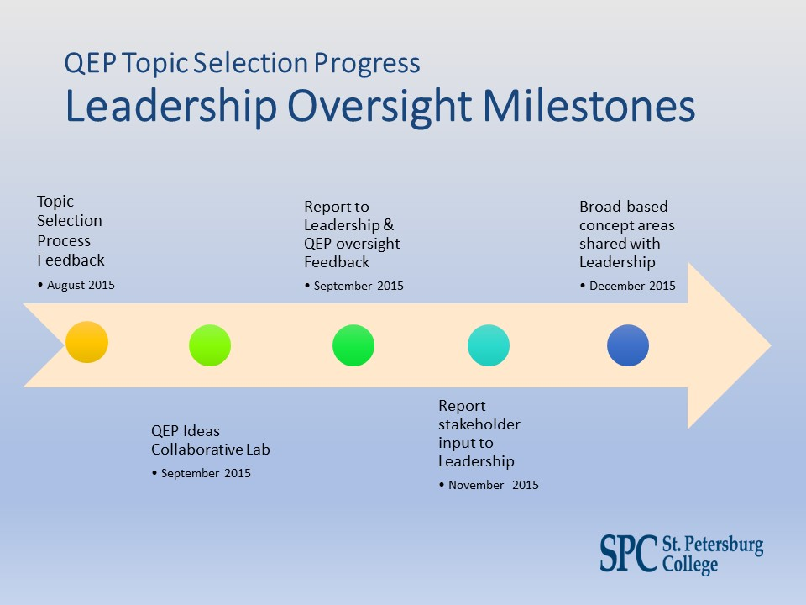

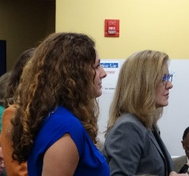
Jennifer Haber, QEP Faculty Chair: We’ve been very busy. Between September and October, we hosted 14 open forums to talk to faculty, staff and students about broad-based concept areas. We talked to about 150 faculty and staff to get their perspectives. We had an online forum and were able to capture the ideas from those people. This was a way to pose a question like, “What is the greatest need?” We took careful notes so we could look at the qualitative ideas.

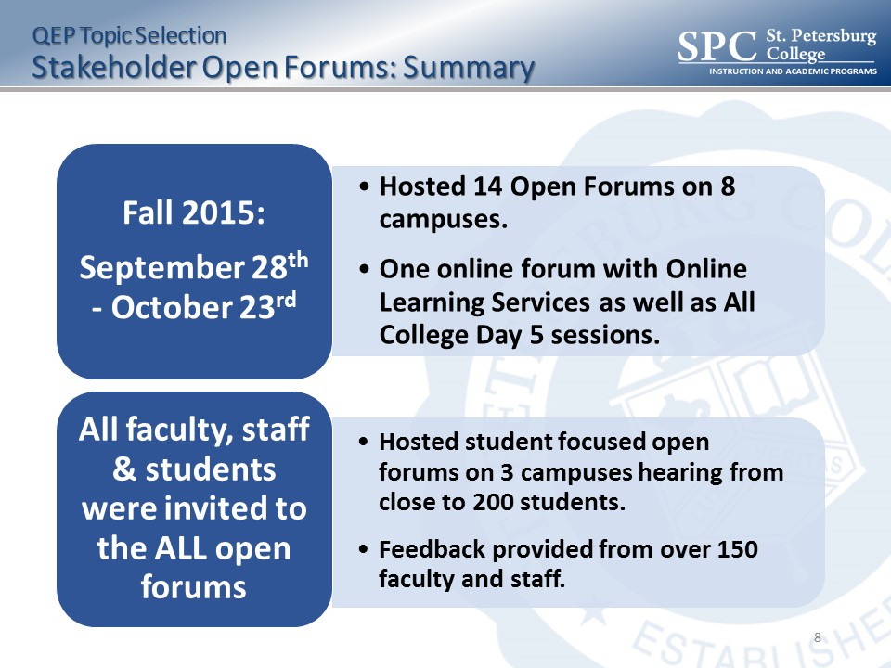

We went to three campuses and talked to 300 students. They had some of the same ideas and some different ones. My favorite was the collegiate high school. They wanted to talk.

There were seven original ideas that came from the Collaborative Labs. Then we created a Wordle. Students, engagement, first-year, cohort – these were some of the ideas that were captured.
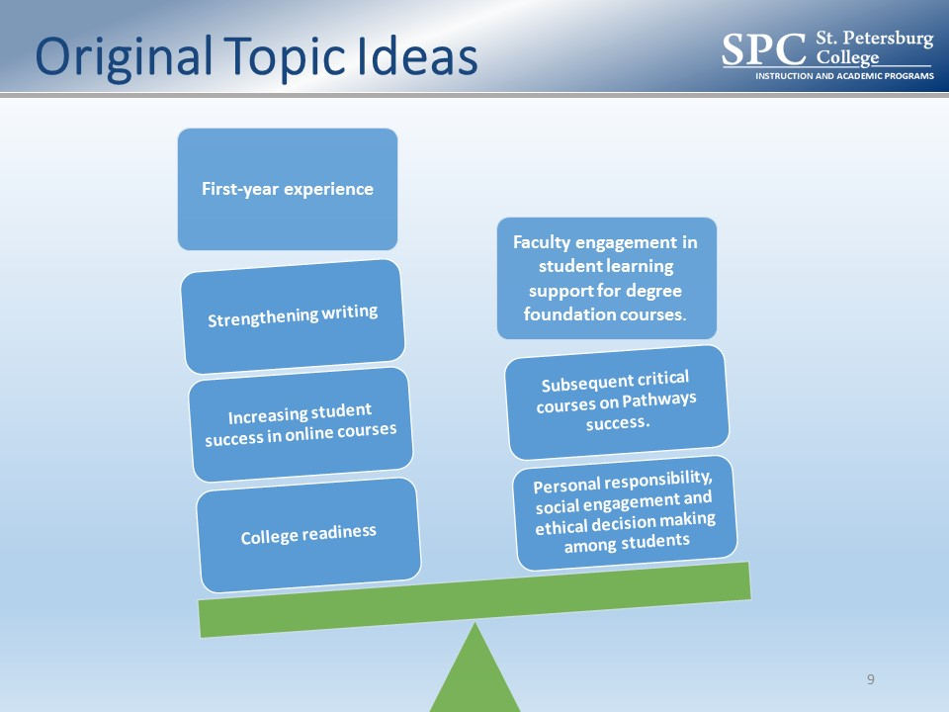

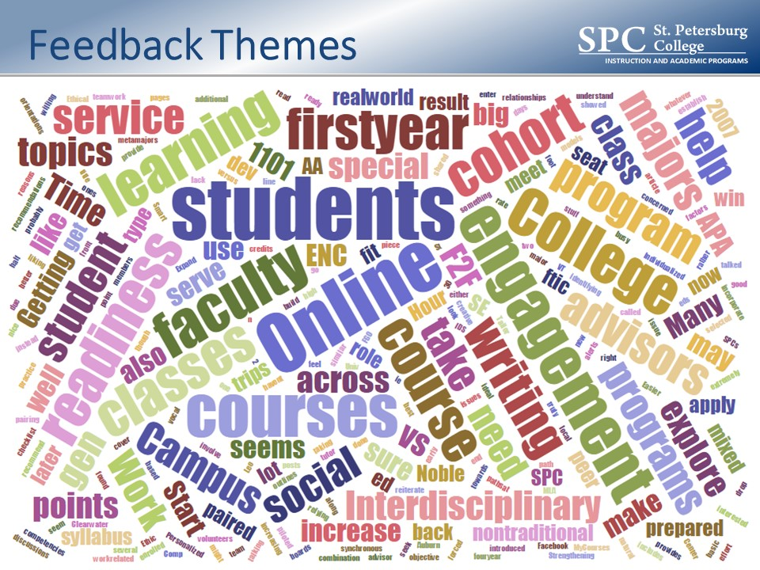

These were the top four broad-based concept areas: 1st year experience, strengthening writing, college readiness and online experience. There were related supporting strategies. You can see some of the things that support the top four concepts. These supporting strategies came up in the dialog with students, advisors, faculty and staff.

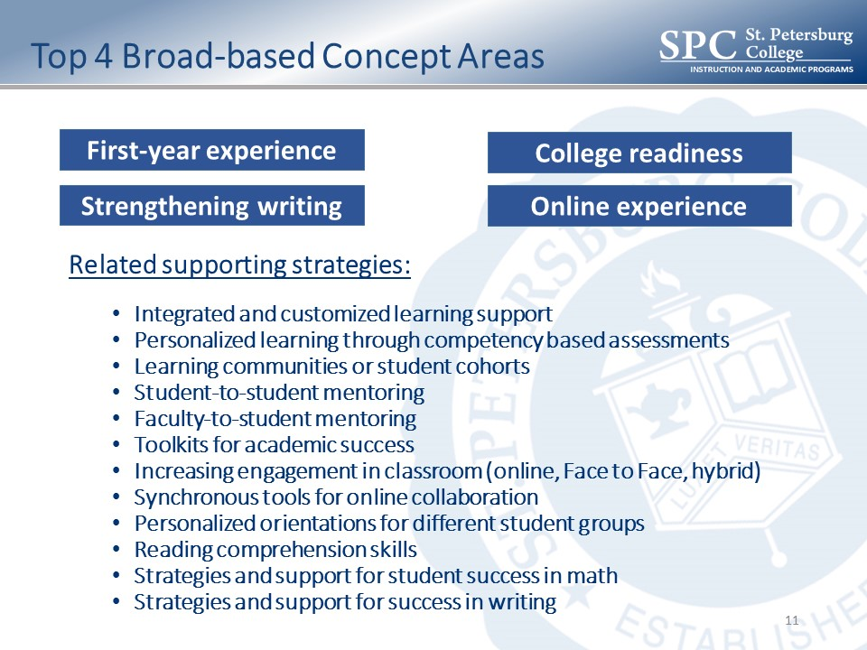

Stakeholder surveys: We wanted to involve the workforce. We sent a survey to the workforce. Strengthening writing was the #1 on their list, with college readiness #2. We wanted to match up which items went with what. These were the combined survey results: There were 813 responses from faculty, staff and students. 35% for College readiness for long-term success. Writing was #2.
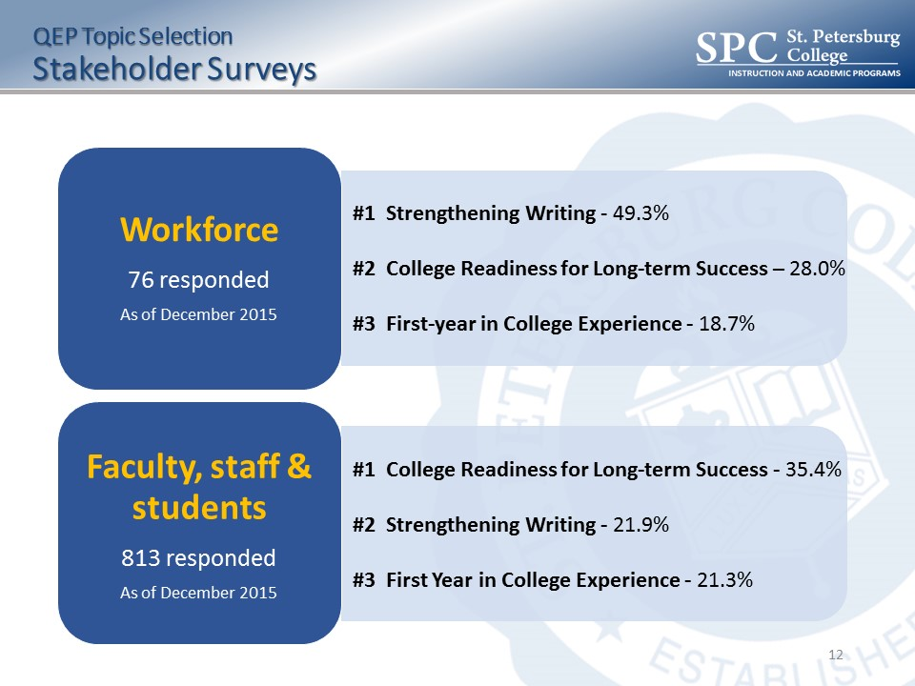

We asked what strategies they would see as a need. Mentoring. Peer-to-peer mentoring. Taking students who had completed certain coursework and pairing them with other students. Customized learning support that is integrated with classroom experience. All of these are important. Heather is going to share the top two items and ask for your feedback.

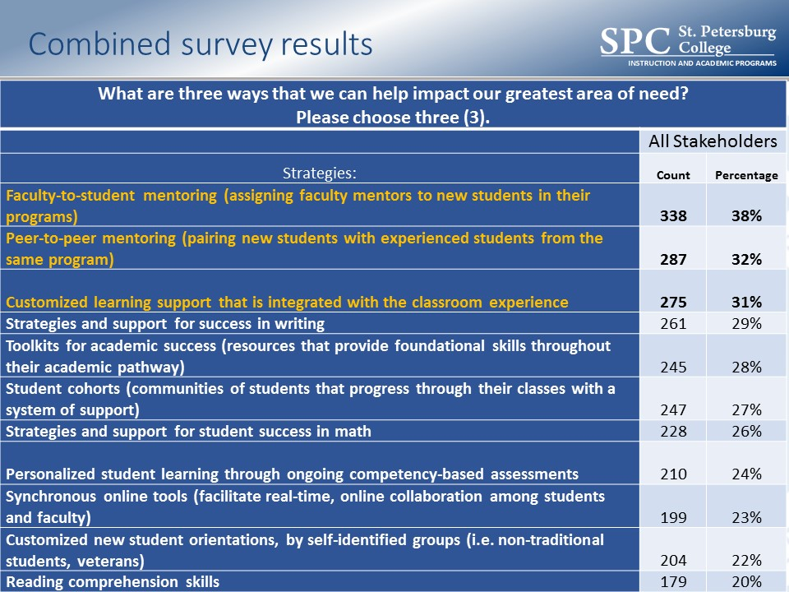

Heather Roberson, Academic Director, Center of Excellence for Teaching and Learning: Your booklet has some information about the top two topics. The number one thing we heard was really the idea of engagement. They felt that it was the driver for success. We asked what our students’ favorite class was. Over and over it was the relationship with the professor - so they felt vested in the class, connected with the resources and so they could finish strong.

#1 – college readiness for long-term success. We have some bullets that will be honed as we move forward. Have a cohort, mentoring, support for fundamental skills, sequencing courses for students to build a foundation that can be reinforced and carried forward. Integrated and personalized coaching and advising. Also, integrated tutoring resources. We have a rich number, but integrating them would bridge that gap for some students. Coaching for college success skills – study skills, time management, helping them to achieve life/school balance.
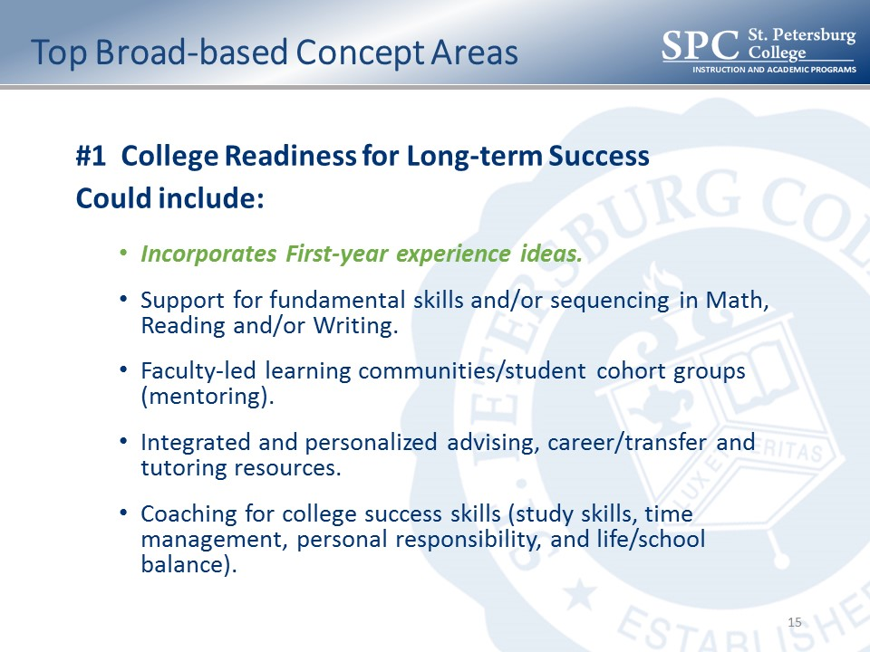
#2 was strengthening of writing. Writing across different disciplines. Fabric of support and not just academic writing. Considering your audience and the purpose of the writing. Assigning a writing coach. Then, the writing experience as a whole. We heard that we don’t have standardized tools throughout SPC. Some Baccalaureate faculty said that they felt like they have to teach them how to write again.

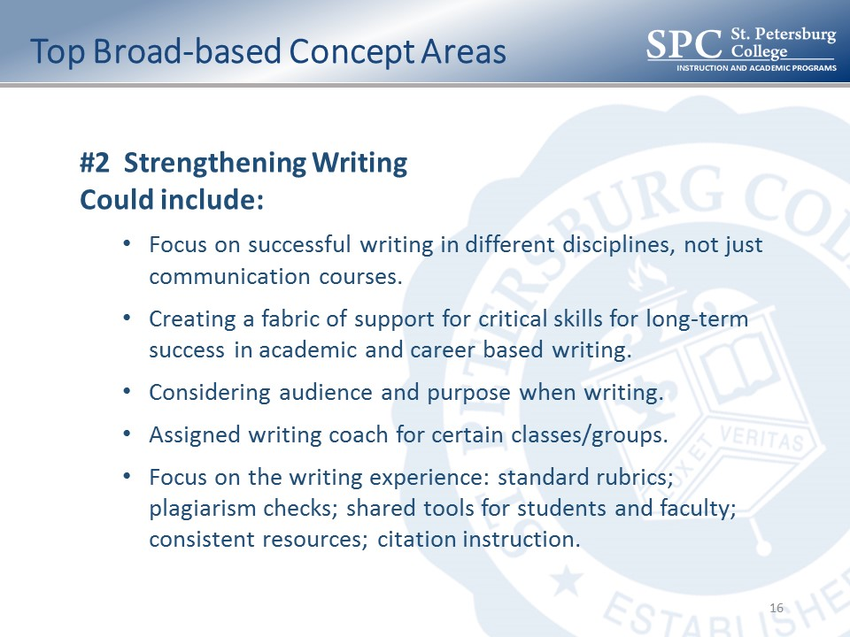

SACSCOC Annual Meeting: We learned something to help us focus. It has to be a well-defined topic related to student learning success. This should not be a burden; it should be something we can weave in. It does not need to be large-scale this time around. They are telling us what we need to do differently this time around. Really hone in on measurable student outcomes.

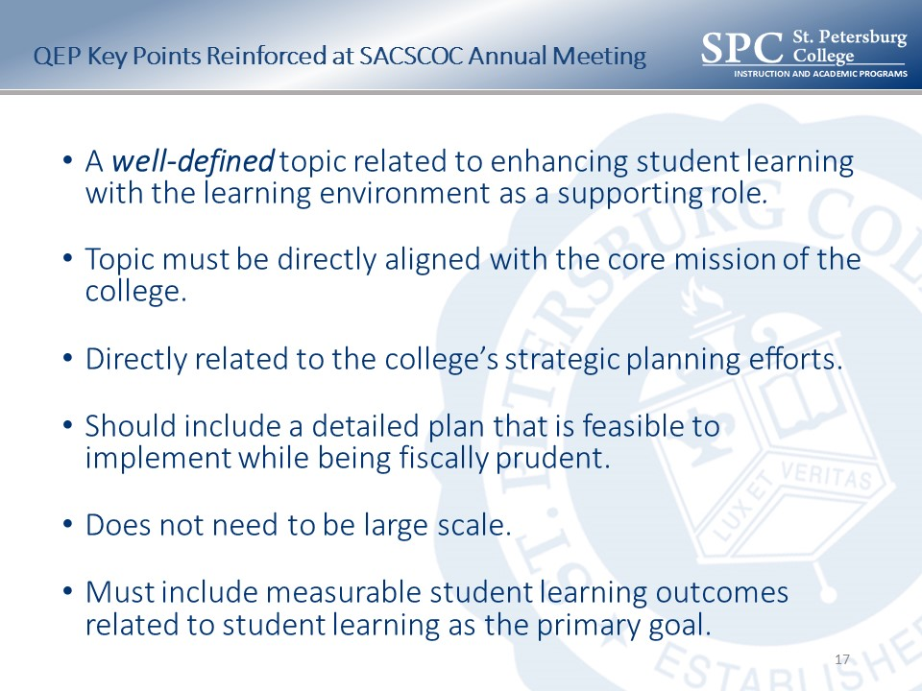

Next steps: We’ll come back in the spring and continue to finalize the topic selection. We’ll return to the Board of Trustees in April with very focused information. There is a SACS Summer Institute that we’ll take some QEP members to. We’ll be writing from fall all the way through May. We’ll submit it to SACS in August in 2017. The final review is in October 2017.

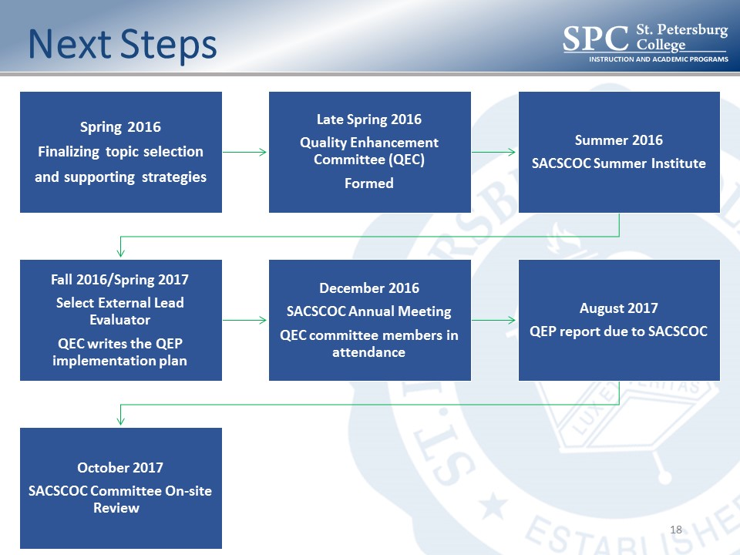

Board of Trustees perspective discussion: Are there any strategies that we need to focus in on a little more?
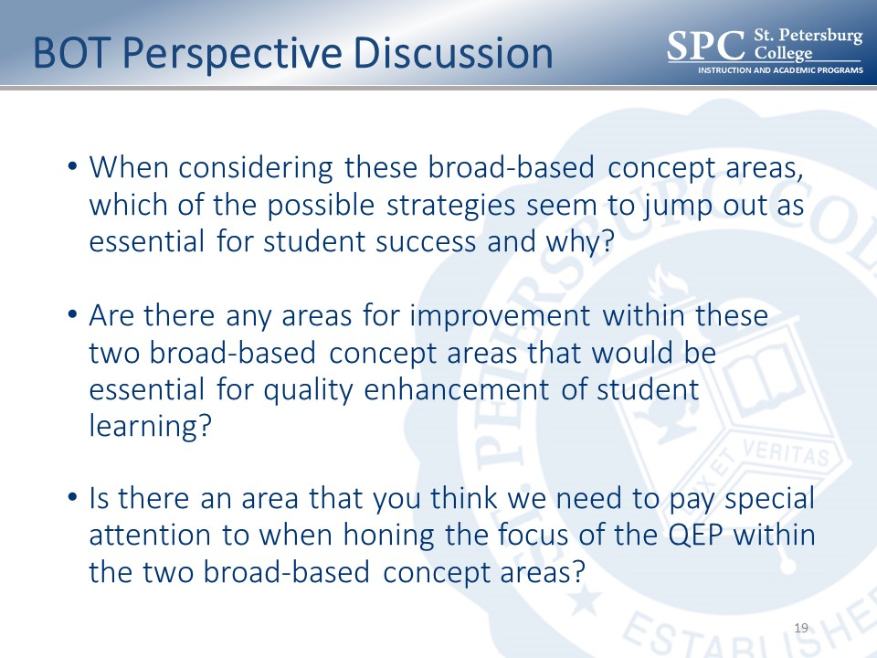

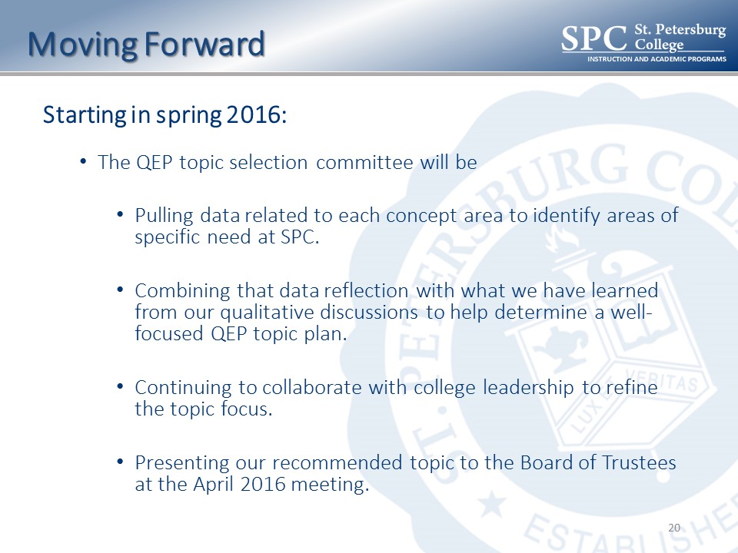

Quality Enhancement Plan Board Discussion

Mr. Fine: Alumni seems to be missing as a stakeholder, especially recent graduates.

Ms. Roberson: I don’t think we sent specific emails to them, but we could focus on them.

Mr. Fine: Recent graduates in the workforce.

Ms. Roberson: We could do a focus group as well. This is the middle of the process. We definitely have time within the next four months.

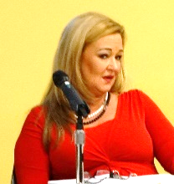
Ms. Bello: With three sophomores in school, I can tell you how they’ll do based on what they think of the professor. My daughter said, “They tell me one thing and do another and didn’t hand out the study guide.” It’s a trust thing.

Ms. Roberson: It’s totally a trust thing.

Dr. Haber: They also want online resources. They want a calendar, a study guide.

Mr. Gibbons: Jack Kemp told a story about the quality of his staff. He would only hire staff from Eckerd College because they were very strong writers. I thought that was unusual that a very small school would be recognized for writing. We’re known for learning labs. I would like to be recognized for writers, mathematicians. Not from the standpoint of writing a school paper, but about writing a business plan and other things within an organization. They are hard to find. We found maybe 20 people in the whole Tampa area who were qualified. We asked them to write something on the spot. Some of them couldn’t write on the spot. This writing piece is important. We can’t do it without funding and the legislature has to listen to us. We have the quality faculty and staff and administration to be the school to put out strong writers and mathematicians in those fields that matter.

Dr. Law: It looks like we have 6,000 students enrolled in Comp I and Comp II. It’s a big important part.

Mr. Gibbons: How do you assess as you make gains with the poor writers and the middle of the roads and the good ones?

Chairman Oliver: The process really honed you in on the two key pieces. The readiness piece. The legislature defeated our ability to work on this. Orientation and Smart Start is kind of our way around that. Going back a lot of years, I think there was a connection to your professor. High school they have the connection. Community college is a good transition. The instructor – if you’re not going to do what you say you’ll do, that’s reflected in the output of the folks you are attempting to lead. I read a lot of stuff – I know what the bad stuff looks like. Even from very educated people – it’s just bad. Make it more fundamental at this level; down the road it will be better. These two items really keyed in on these two issues.

Mr. Gibbons: As a young athletic student, coach had a rule, you had to come in the summer to remediate. It did make the transition to college easier. Going over the things you were supposed to know. I’m a fan of remediation. It was very helpful. When there are 500 people in the classroom, you have to know what to do to be successful. I think the remediation piece is important and we have to figure out how to get it back. It only puts more of a burden on the faculty. We have to be able to do this to help the students that need this. We’ll go back to the legislature.

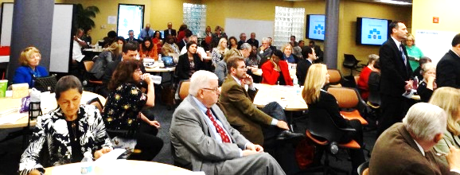

Dr. Law: I’m looking at Martha Campbell, who is probably the most knowledgeable about this. Comp I and Comp II are only at the middle, it’s not the whole thing. Dr. Campbell would say, if you don’t read, you don’t write. We want to work on the remedial piece. We did it with your leadership, the highest portion of our budget goes to instruction, student support and out of classroom support. We have the framework and we can build on that. We’ll get down to, “Which of our kids do we love best?”

Ms. Bello: Chairman Oliver said something earlier about keeping it simple. My daughter’s professors didn’t care about the writing, they cared about the content. The attention to detail is part of it. For me, resumes with misspellings go in the trash.

Dr. Law: We have the ability (Smart Thinking) for students to get feedback on their writing. None of this is new to us. There is a long way to go on both of these.

So, you will be back in April. There is more work with our constituents. We’ll look at alumni. Keep faith with the business community, faculty and staff. We’ll come back with suggestions on these. One has to be our submission to SACS. I want to compliment the leadership on this project. They committed to be enthusiastic for the dialog across campuses with the goal of being here this morning with a proposal and they’ve done that.

9:50am –  10:20am | The College Experience  This session will provide a summary of the impact of the ongoing 5-part College Experience Project. Particular attention will be given to changes in the orientation component and in the career support and placement activities. Overall impact of the plan will be discussed and next steps in the evaluation and design of the components will be presented.  This session will result in guidance from the Board on areas of emphasis for the College Experience components in the Spring 2016 semester and in the 2016-17 academic year. | Topic 2 (30-min.):  - 5-min. “Just the Facts” Overview  - 20-min. Collaborative Discussion in teams  - 5-min. Team Reports:  Top 5 Considerations for 2016

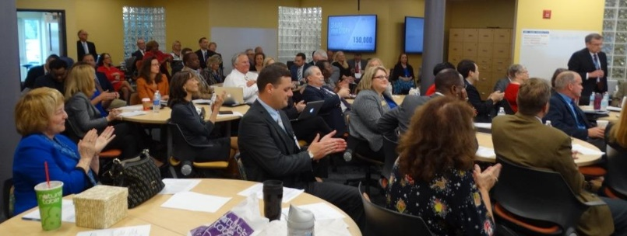
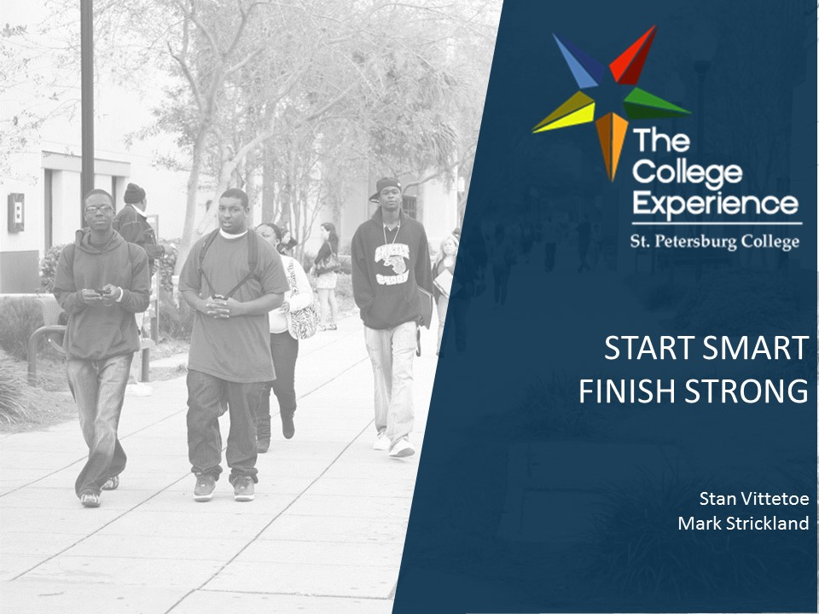

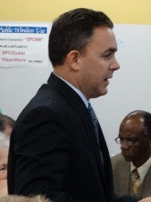
Mr. Mark Strickland, Provost, Seminole Campus: We’ll try to speed it up. We’ll cover each of the five components of the College Experience. Every Wednesday at 8:30am sharp, the College Experience is presented. We have more than 100 folks on the line. The work is significant. There has been national recognition. We have presented at Achieving the Dream.
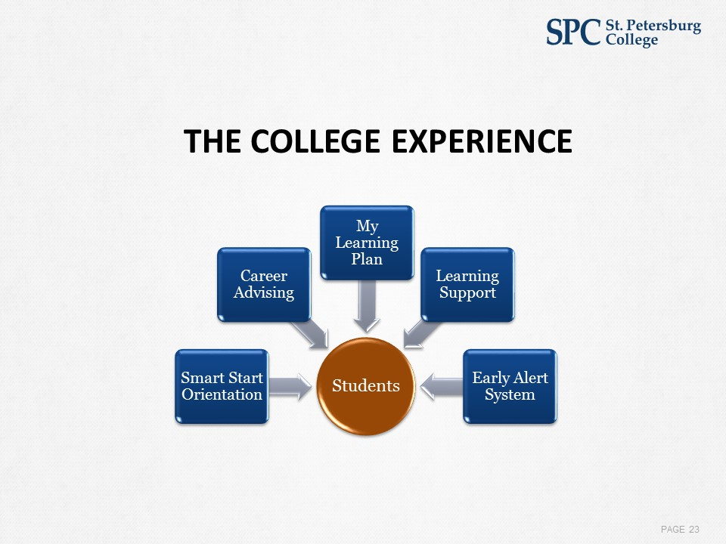
Smart Start Orientation stats: 65% of students that were successful in the fall have already registered for spring. Unsuccessful - 29% registered. If you were successful in Smart Start, you were more successful and have a higher percentage of completing a Learning Plan and fewer early alerts.
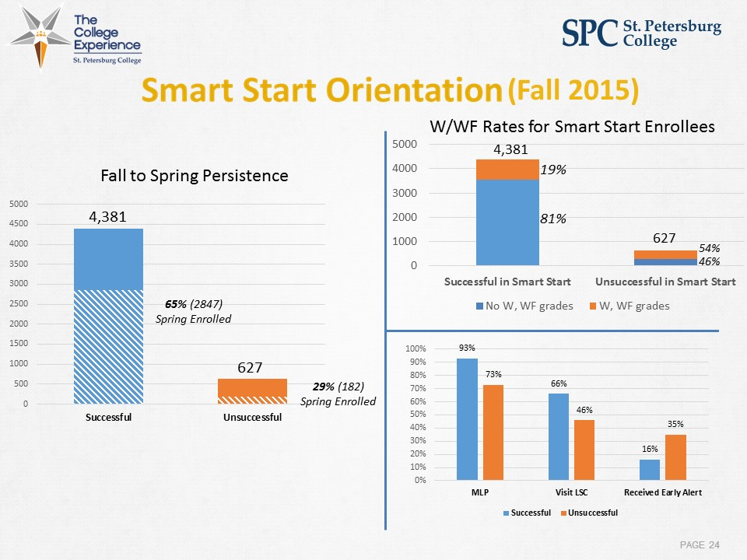

Dr. Stan Vittetoe, Provost, Clearwater Campus: Of all the five components, the most ambitious was the enhanced services in the area of career services. There has been extensive remodeling of the career service centers. Over 100 advisors have taken over 120 hours towards certification which will be completed in March. We’ve had 177 events, 196 classroom presentations. Of 1,700 graduates, nearly 80% are either placed or prepared to transfer to another institution.

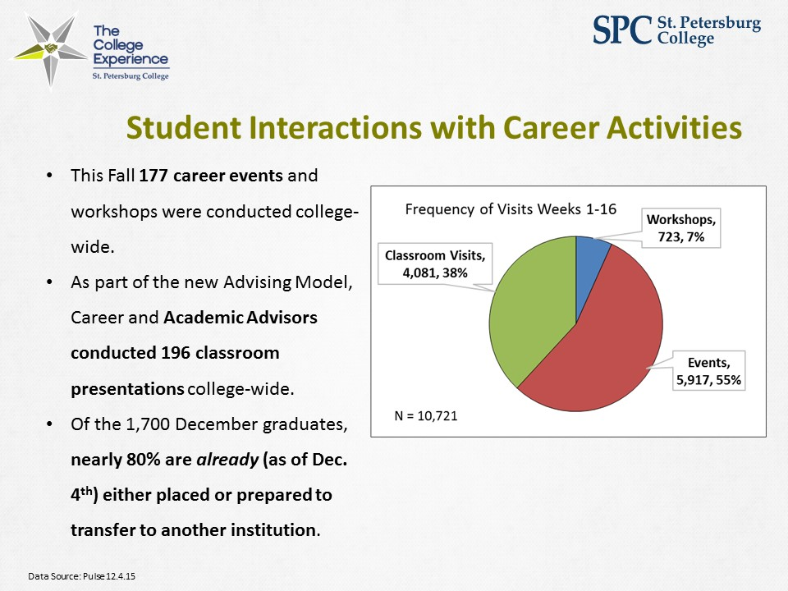

Variety of services: Smart start and Finish Strong participation has been growing.

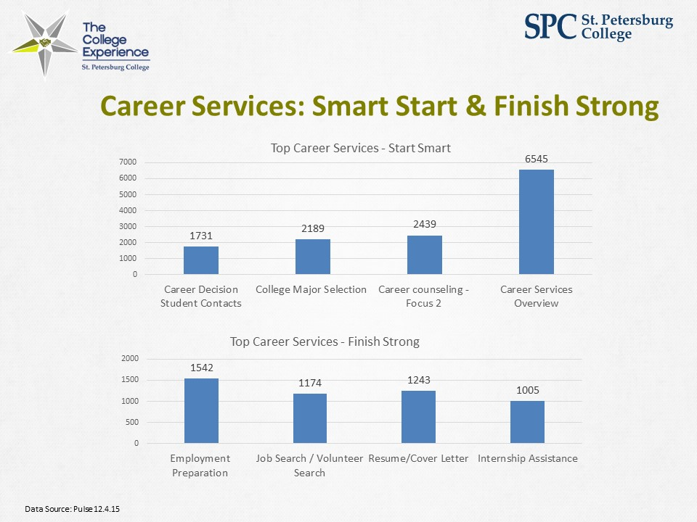

My Learning Plan: Covey said it first: successful people begin with the end in mind. A plan. Students who complete the plan have a 20% higher success rate and a lower withdrawal rate. We’ve developed a feature list of the optimal planner. In February, we’ll begin a pilot of a new learning plan. One that is more fully integrated with our systems - PULSE and People soft and Illume. We’ll expand the pilot in April and by this time next year, we should have it open to the entire student body.
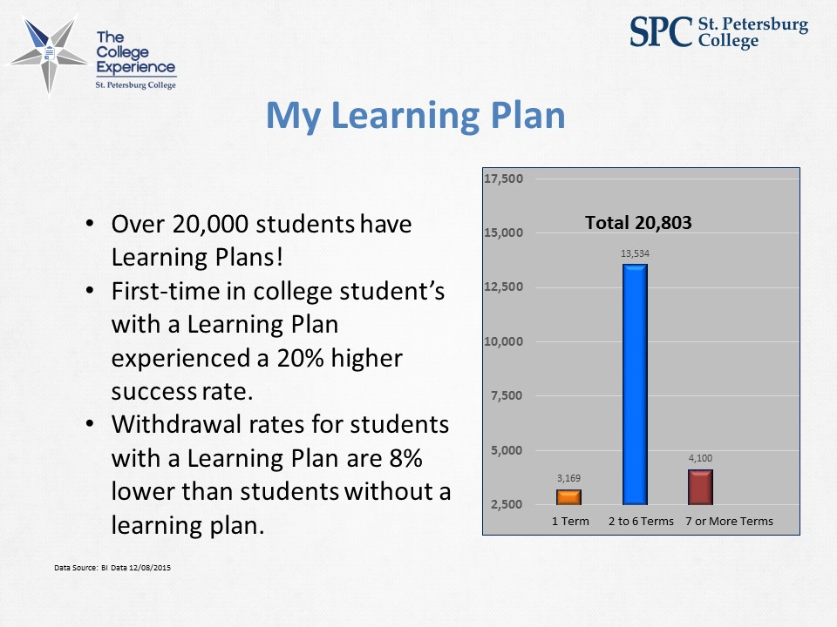

Mr. Strickland: Early Alerts. There were 3300 opened this fall. Ninety-nine percent were closed out. Not all were successful. We have a Collaborative Lab slated for January to come up with best practices to make it better.

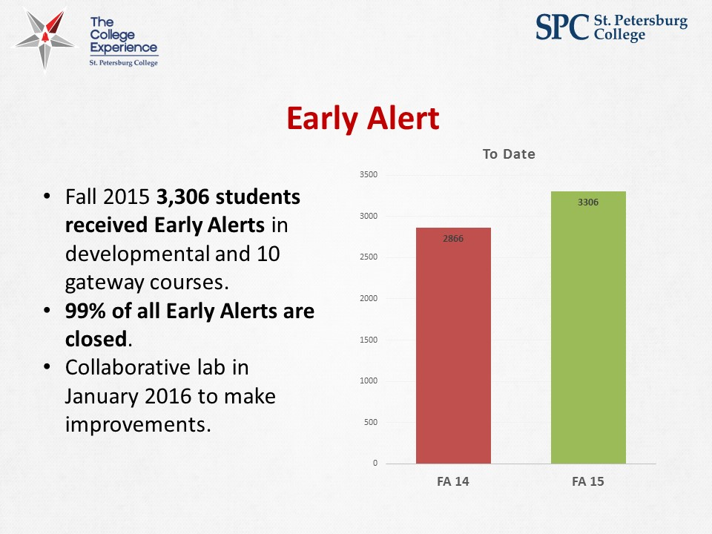

Out-of-classroom support: Increase in faculty support. Integrated advising and learning components. If an early alert goes out, it goes to the learning commons.

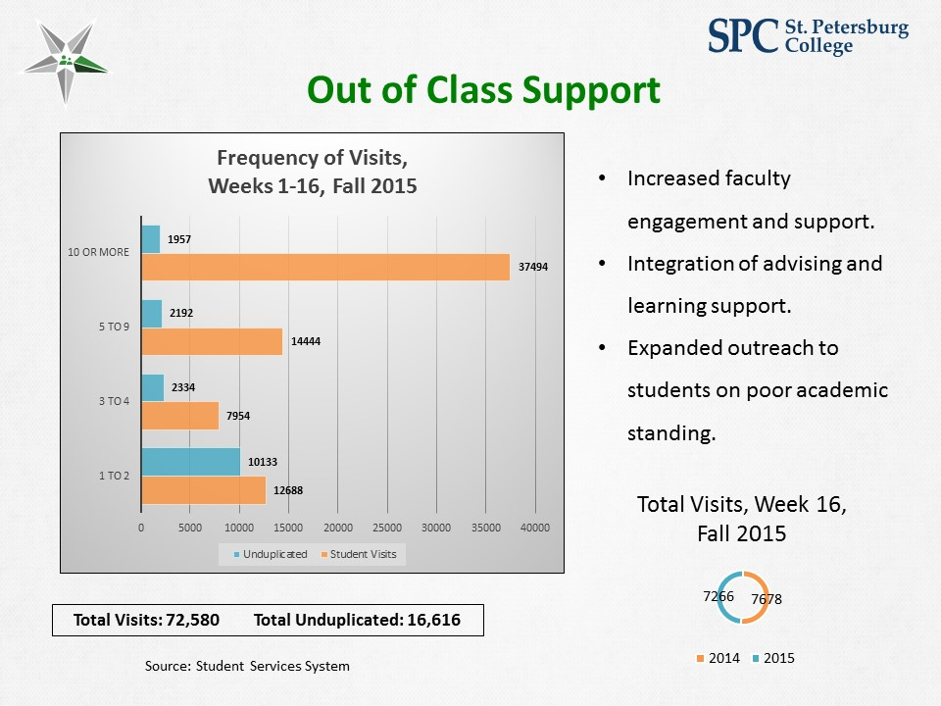

Dr. Patrick Rinard, Associate Vice President, Enrollment Services: We need to go what Dr. Williams calls dumpster diving – find problems and solve them. I was challenged to get the diplomas to students sooner. The diploma wasn’t getting to the student until four or five weeks after graduation. Thanks to the work with IT and others, they will go out this week.

We are also letting students know where they are relative to the finish line. We found 350 students who had completed everything but hadn’t applied for graduation. We’re graduating them this week.

Dr. Law: I hit the ball at Patrick as hard as I could. The worst nightmare is that late in the semester the student is told they are not ready. We are now looking at it much earlier. We learned that 350 students just didn’t fill out the form. Our continuous effort to get information, sort it out earlier, get it to students earlier. Getting diplomas in students’ hands. I’m proud of that work. Great job, Patrick.

Mr. Strickland: Next steps: We want to make sure that the other 13,000 have Learning Plans. Get national certification for advisors and focus on early alerts and Learning Plans.

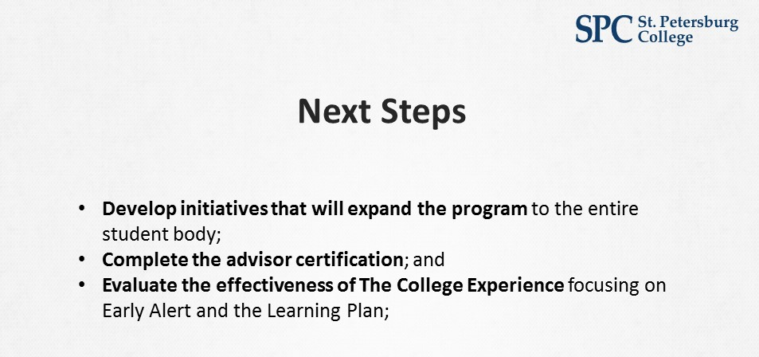

Dr. Vittetoe: These are the questions we would like you to consider in this area. We put the whole weight of our efforts to first-time at SPC students and we want to expand that.

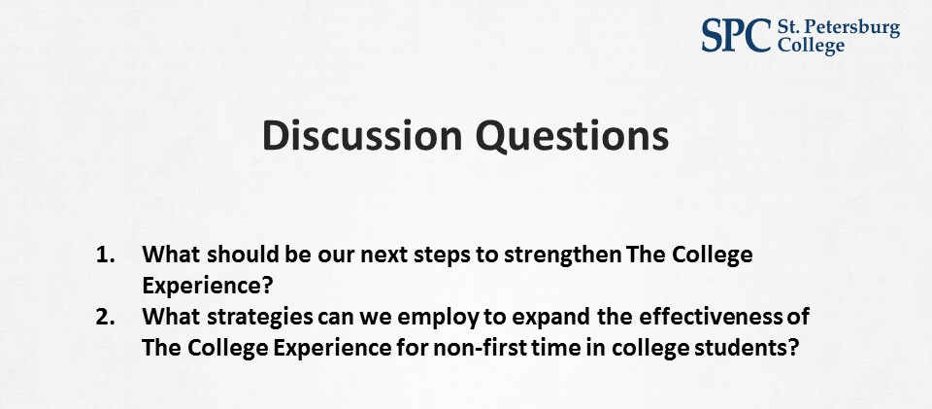
Andrea: You have your first team assignment. There are four teams. We’ll head to Forest and we’ll use our brainstorming software to capture your ideas on these two questions.

Team Assignments

The College Experience
Team 1  - Dale Oliver, Board of Trustees  - Jason Krupp, Director of Workforce Services  - Jesse Coraggio, VP Institutional Effectiveness and Academic Services  - Jonathan Steele, Dean College of Humanities and Fine Arts  - Marvin Bright, Provost  - Richard Flora, Dean School of Veterinary Technology  - Sharon Setterlind, Dean College of Computer and Information Technology | Team 3  - Anne Cooper, SVP Instruction and Academic Programs  - Deveron Gibbons, Board of Trustees  - Heather Roberson, Academic Director, Center of Excellence for Teaching and Learning, Academic Programs  - John Chapin, Dean Natural Science  - Joseph Smiley, Dean Social and Behavioral Sciences  - Rebecca Ludwig, Dean College of Health Sciences  - Theresa Kontodiakos, Student Services Manager
Team 2  - Brian Frank, College of Public Safety Administration  - Bridgette Bello, Board of Trustees  - Greg Nenstiel, Dean College of Business  - Kimberly Hartman, Dean College of Education  - Susan Demers, Dean College of Policy Ethics and Legal Studies  - Tonjua Williams, SVP Student Services  - Tyrone Clinton, Associate Provost | Team 4  - Doug Duncan, SVP Business Services and Information Technology  - Jamelle Conner, Provost  - Jimmy Chang, Dean Mathematics  - Martha Campbell, Dean Communications  - Robert Fine, Board of Trustees  - Susan Baker, Dean College of Nursing

The College Experience Team Reports

1. What should be our next steps to strengthen The College Experience?
1. Continue to expand services to additional students
2. Simplify processes - link logically (e.g. leverage data from Learning Plans)
3. Incorporate discipline-specific learning communities
4. Embed successful students (i.e., Peer Advisors) into Smart Start
5. Add online student services
6. Create and encourage a competitive environment to challenge each other academically- within Smart Start
7. Behavioral nudges: encouraging activities
8. Continuation of Smart Start courses later in the semester
9. Consider credit for Smart Start
10. Students should be able to accomplish all student services online and they should have a clear process map articulated to them.

2. What strategies can we employ to expand the effectiveness of The College Experience for non-first time in college students?
1. Current students are looking for cohorts (commonalities) among their peers- QEP study feedback
2. Track according to milestones (#credits completed towards program of study) and send appropriate just-in-time communications
3. Expand internships
4. Adding online service component
5. Expand effort to formalize student support as an essential component to the College Experience
6. Identify goals of non-FTIC students (e.g. returning students, skill-development focused)

3. Top Considerations for the College Experience in 2016
1. Expand use of communication and notification features of My Courses
2. Each course, including Smart Start, has an assigned math and writing tutor- Expand effort to formalize learning/out-of-class support as an essential component to the College Experience. This should incorporate peer-to-peer tutoring/mentoring.
3. Follow up with those who don't complete Smart Start and who were successful as well as those who weren't
4. ADD ONLINE SERVICES FOR ALL STUDENTS
5. Prepare students for graduation - Communicate proximity to graduation, push career services
6. Merge college experience with academic experience
7. Contextualize lessons according to academic disciplines

Team 1

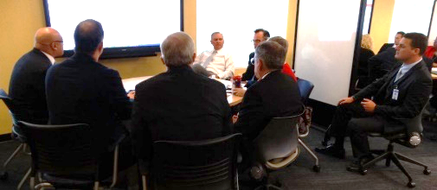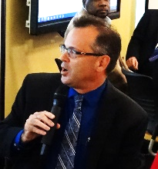

Dr. Coraggio: How do we personalize? Proximity and providing service. Merging College Experience with the academic experience. Smart Start/Finish Strong with the College Experience providing the background service. Wednesday and Friday webinars – similar things – have those conversations come together. Contextualization lessons according to academic disciplines on the service side.

Team 2

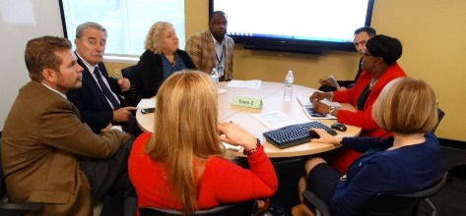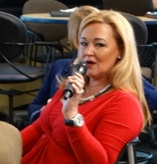

Ms. Bello: Tonjua put it best – when you go online on your bank site they tell you how to do the process. If they didn’t have to sit with somebody, they would do it online. I want to transfer to Florida State in marine biology, here’s the classes, here are the toxic classes – get a red alert. So they don’t have to have a conversation with somebody based on the end goal. Have the new software that can read the transcripts. Constantly communicating with the student.

Team 3

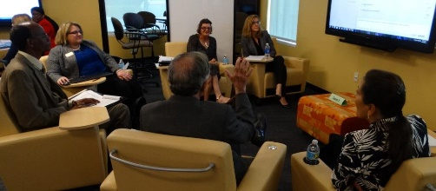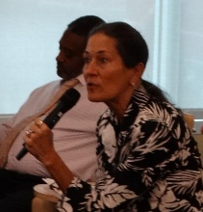

Dr. Cooper, Senior VP Instruction and Academic Programs: We focused on out-of-class support. Where and when they can find it based on discipline areas. Peer-to-peer student tutoring and mentoring. Smart Start – meet a mentor and tutor for writing and math – start to build the relationship.

Team 4

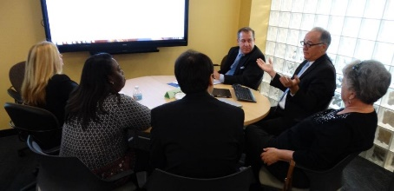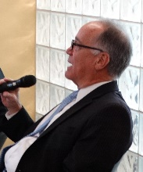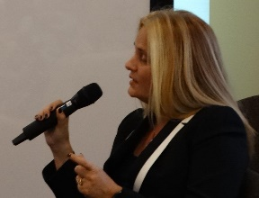

Dr. Doug Duncan, Senior VP Administrative/Business Services and Information Tech: Using the capacity of MyCourses as well as more consistent use by faculty. Early Alert is very labor intensive and limited in scope. Alerting them in a more comprehensive manner and we should expand it and use the more in-depth features.

Ms. Jamelle Conner, Provost, St. Pete/Gibbs Campus: Our second one was #3. Follow up with people who didn’t complete Smart Start. We need to research the characteristics of those who didn’t complete. Also those who completed and were successful. And those who didn’t complete and were successful.

Andrea: Thank you, teams. We’ll meet you back in the Tropics.

10:20am –  11:00am | The Classroom Experience  This session will be new in its scope and presentation. The Board will be guided in its review of the experience of students in courses and programs. Rather than focus on support services (as contained in The College Experience), this new focus will begin to build a sharpened focus on the experience of students in the classroom, toward a better understanding of student preparedness, changing student demographics, new technologies available for learning, and the refinement of courses within the recently established Academic Pathways. This session will also identify the kinds of data, information, and metrics desired to support faculty classroom efforts.  This session will result in a renewed focus on the successes and challenges of faculty in the delivery of instruction, toward the goal of identifying appropriate changes in policies, procedures, or allocation of resources. | Topic 3 (40-min.):  - 5-min. “Just the Facts” Overview  - 25-min. Collaborative Discussion in teams  - 10-min. Team Reports:  Top 5 Considerations for 2016
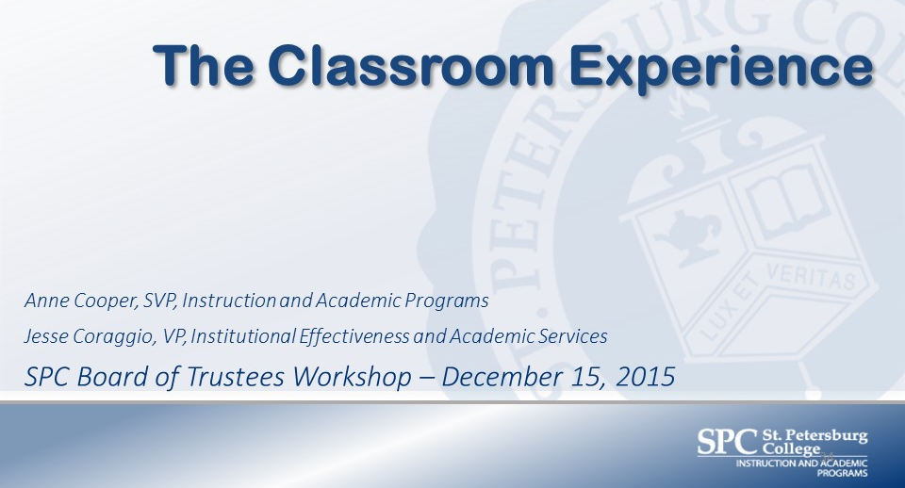

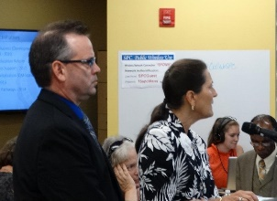
Dr. Cooper: As you’ve been hearing, much has been done with the College Experience to be sure students arrive at their classes ready to learn and be successful. On the academic side, we’ve been looking at things we can do to help students. Bridge to Success – focus on competencies they need to strengthen. General Education Reform – general core classes so there are fewer differences if students transfer. We looked at our own curriculum so the learning outcomes were embedded in the program. We looked at how we can change the culture around learning centers and out-of-classroom support. We wanted students to see that the learning centers were the hub. Many faculty are giving their time in the learning centers.

We’ve been looking at online courses. We hadn’t spent enough time on the quality of online courses. We made the decision to adopt the Quality Matters standards. The standards are in your booklet as well as the rubric for those standards. Faculty recognized that this is something we should be doing for all modalities, not just online.

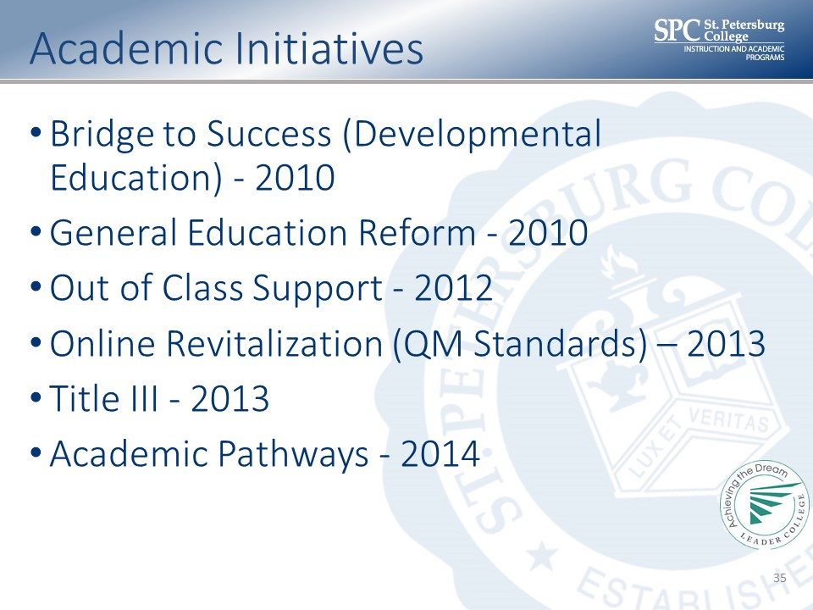

Quality Matters rubric: We are focusing on introductions and learning activities that support interaction. It’s important to engage students.

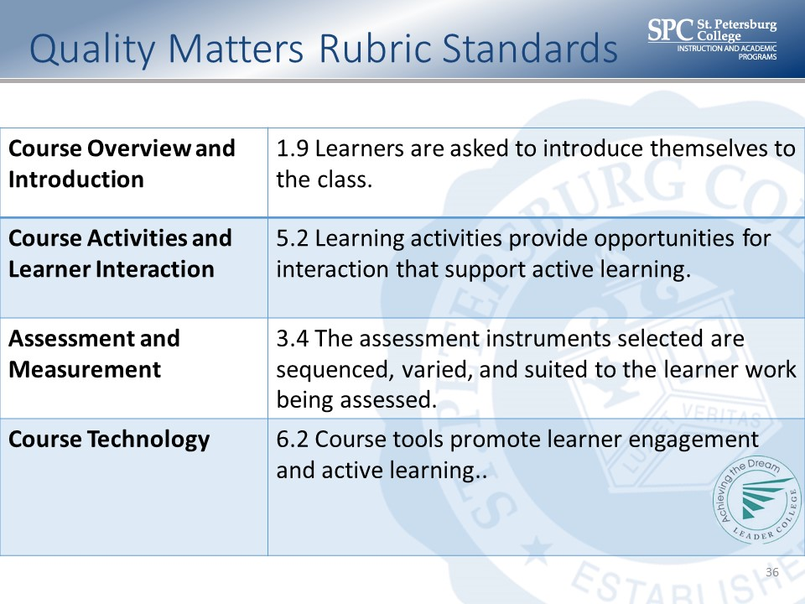
Academic initiatives: We are using a Title III grant for tool kit initiatives. Students can use them to practice. In 2014, we created academic pathways so students have a clearly defined path of courses from beginning to end.

Classroom Experience: We embedded activities like internships. Readiness skills are embedded in the program. We want them to be ready to interview; some have found jobs before graduation. We created milestones to monitor progress. I’ll ask Dr. Coraggio to share some data to demonstrate success.

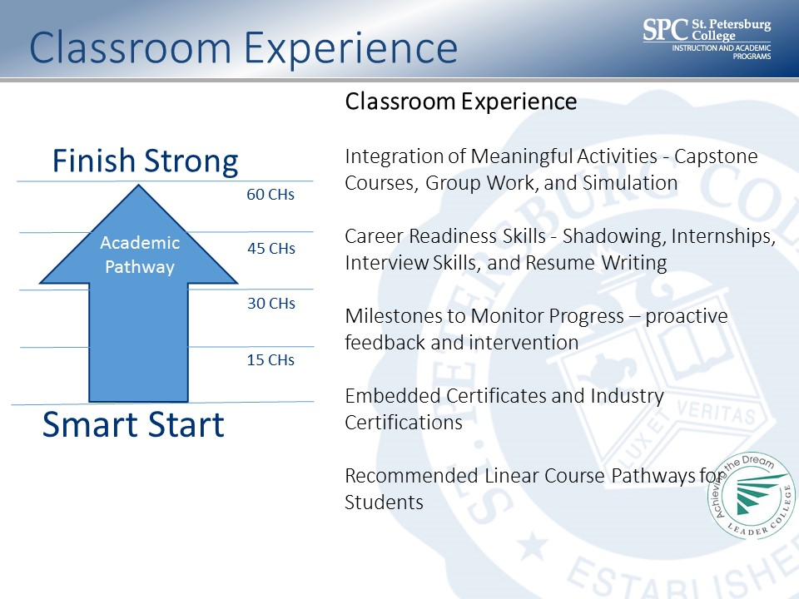

Dr. Coraggio: Student success matrix. We pulled this data a few months ago. It’s the percentage of faculty teaching courses. These are the not A, B, or C grade students. About 16% of the faculty have about 40% of the non-successful students. There are variables to consider, but we’re looking at the data. It helps us move the needle on student success.

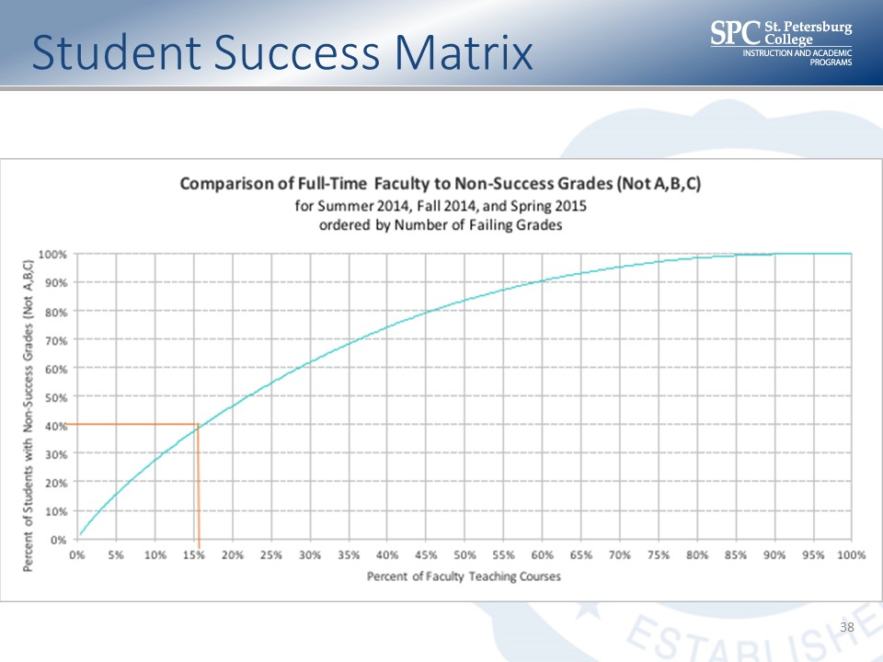

CCSSE Benchmarks: We looked at the two most recent administrations in 2013 and 2015. We focused on in-class data. We’ve made improvements. You have the detail on two of the benchmarks: Active and collaborative learning and student-faculty interaction. This includes outside the classroom. The benchmarks where the mean is 50 and the standard deviation is about 25. We’ve made a little bit of improvement in active learning and a little more in faculty-student interaction.

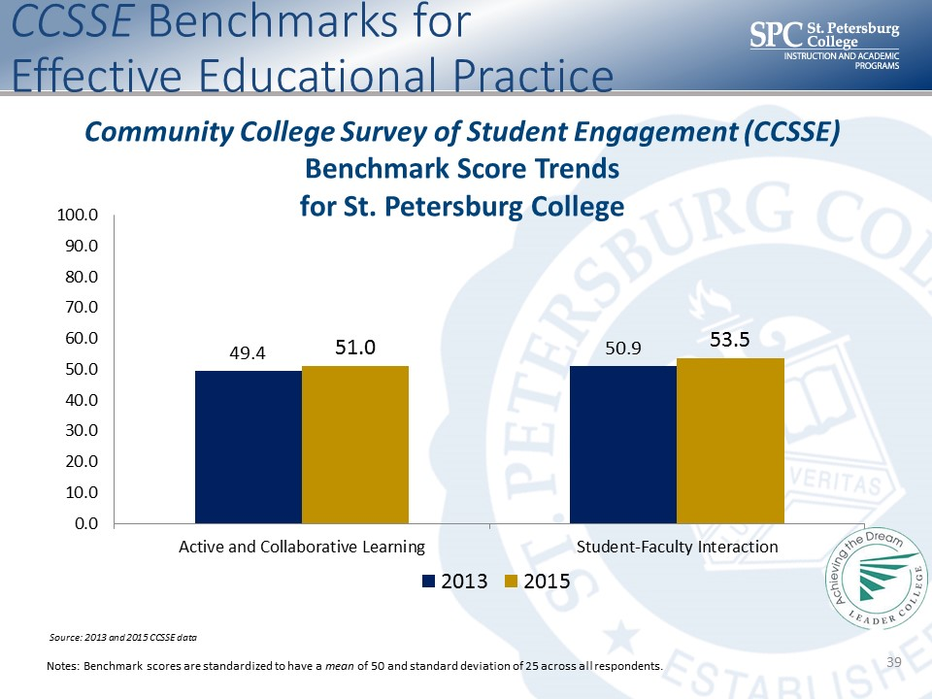

St. Petersburg College vs. top performing colleges. This is how we compare to the top performing schools.
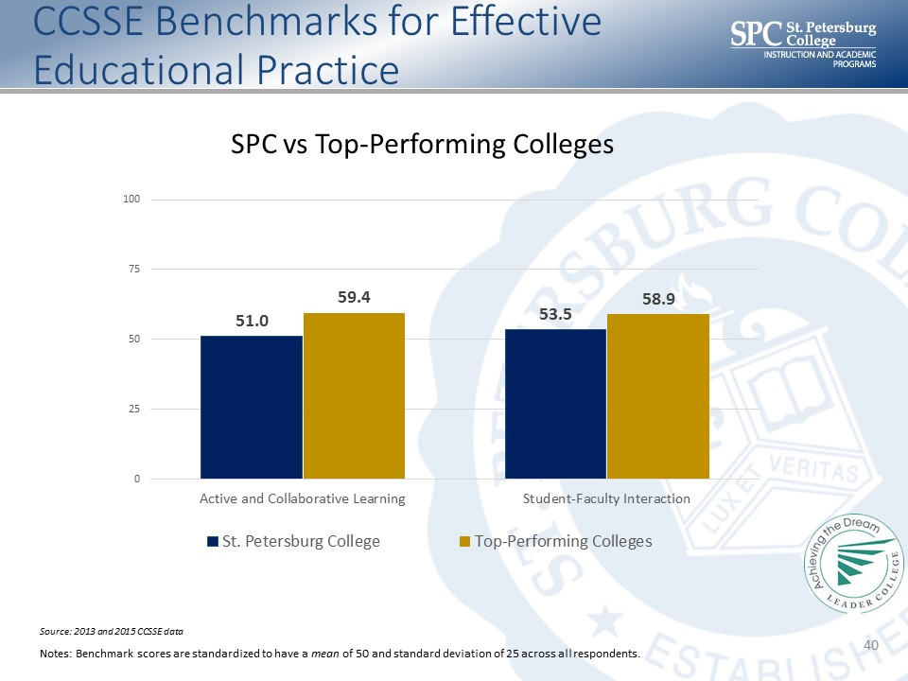

These are our three lowest scores. 4a: Asked questions in class or contributed to class discussions. 60.6% of respondents answered often or very often. Worked with other students – we had 43.6%. Worked with instructors on activities other than coursework. We had 10.7%. We will research the best practices and bring back to you what we think will be the classroom experience.

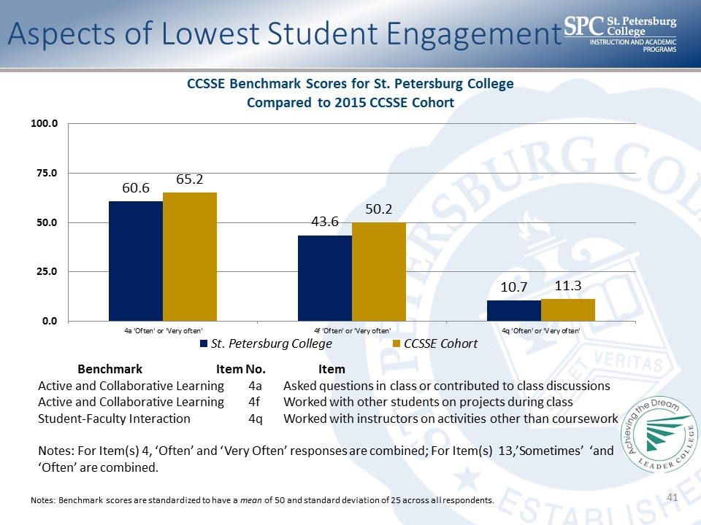

Dr. Cooper: We know students come to us with different backgrounds and skills. Proposed value proposition: Shouldn’t every class create that learning community where they are engaged and experiencing activity-based learning?

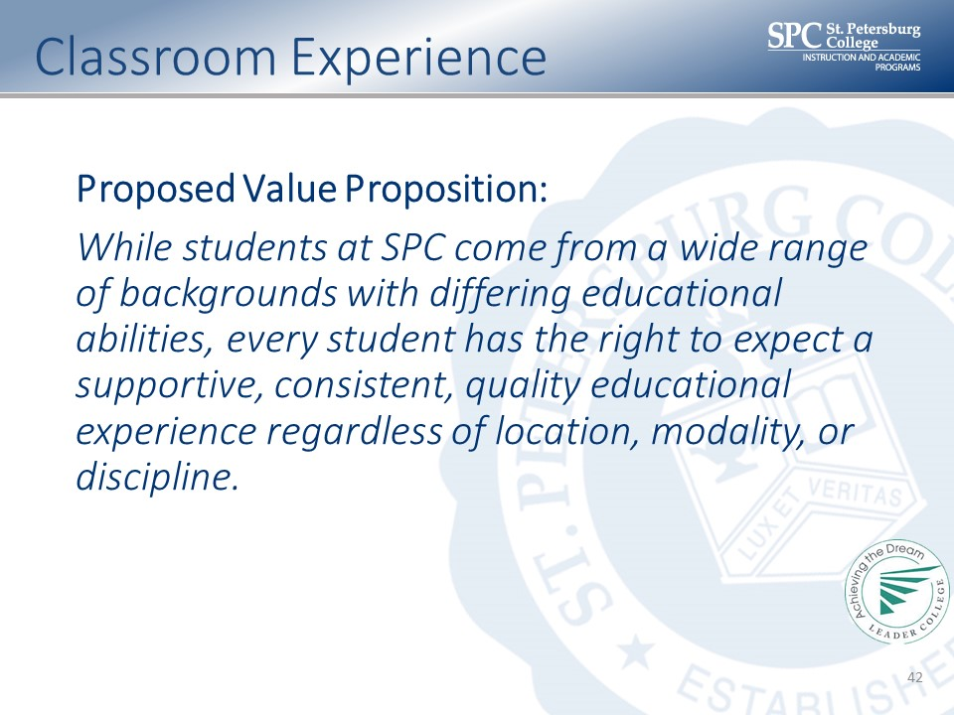

Some questions for you to consider:

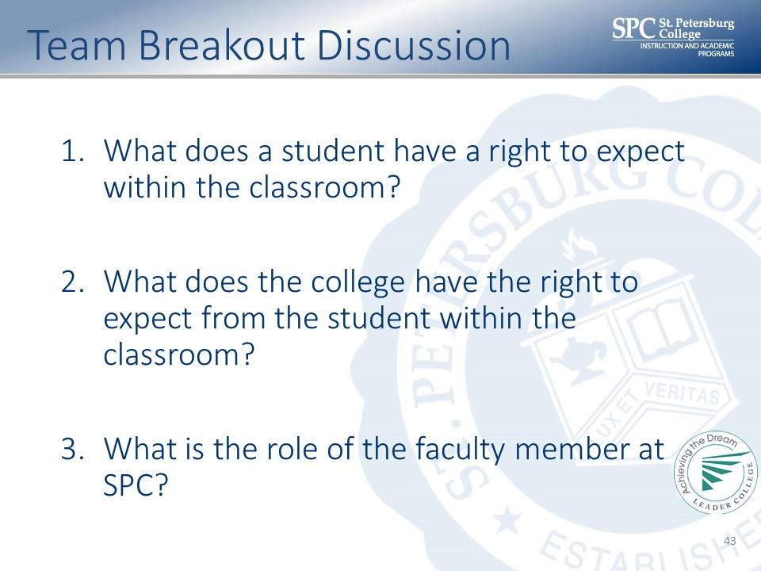
Dr. Law: Are there any clarifications? We go through a very rigorous assessment of our engagement of students. We sound like helicopter parents. We want to do everything so nothing bad happens to them. Eventually, the student has to take responsibility. In the end, what happens in the classroom is really what it’s all about. If the classroom experience is not fundamentally sound, if it hasn’t changed, if it doesn’t recognize the different students we have today, we won’t be successful.

I met with faculty to understand the challenges they face. The hole they are in is pretty deep. The Legislature didn’t help them. Any student can wander into their classrooms. Two-thirds are doing great. The other third, I didn’t get a sense of commitment to the students. We’re going to proceed to get our arms around what’s missing. We’re going to find the good answers.

Mr. Gibbons: The hiring you’re doing is getting there. Through attrition, you’ll get there.

Dr. Law: I don’t think I have the patience to wait. I think we have to put our expectations out there. If a faculty asks for assistance, we have a wide array of resources. We can’t have 40% of students struggling in the classrooms of 16% of the faculty. It’s very hard work when you see what low-level skills that students arrive with. We have to make progress in this front. I can’t keep doing College Experience if I can’t do Classroom Experience.

Andrea: We’ll meet you in the Forest Lab where you’ll consider these questions.

Team Assignments

The Classroom Experience
Team 1  - Anne Cooper, SVP Instruction and Academic Programs  - Brian Frank, College of Public Safety Administration  - Dale Oliver, Board of Trustees  - Jamelle Conner, Provost  - Joseph Smiley, Dean Social and Behavioral Sciences  - Kimberly Hartman, Dean College of Education  - Theresa Kontodiakos, Student Services Manager | Team 3  - Bill Law, President  - Deveron Gibbons, Board of Trustees  - Jennifer Haber, QEC Lead Faculty  - Jesse Coraggio, VP Institutional Effectiveness and Academic Services  - Jimmy Chang, Dean Mathematics  - Martha Campbell, Dean Communications  - Rebecca Ludwig, Dean College of Health Sciences  - Tyrone Clinton, Associate Provost
Team 2  - Bridgette Bello, Board of Trustees  - Doug Duncan, SVP Business Services and Information Technology  - Frank Biafora, Consultant  - Marvin Bright, Provost  - Richard Flora, Dean School of Veterinary Technology  - Sabrina Crawford, Executive Director, Institutional Research & Effectiveness  - Susan Baker, Dean College of Nursing  - Susan Demers, Dean College of Policy Ethics and Legal Studies | Team 4  - Greg Nenstiel, Dean College of Business  - Jason Krupp, Director of Workforce Services  - John Chapin, Dean Natural Science  - Jonathan Steele, Dean College of Humanities and Fine Arts  - Robert Fine, Board of Trustees  - Sharon Setterlind, Dean College of Computer and Information Technology  - Tonjua Williams, SVP Student Services

The Classroom Experience Team Reports

1. What does a student have a right to expect within the classroom?
1. Purpose of course - Learning Objectives
2. Materials/lessons accommodate to learning styles
3. Current materials; up to date curriculum
4. Fairness
5. Respectful and courteous
6. Academic Excellence
7. Clear understanding of academic performance between the faculty member and the student
8. Clear understanding of communication with timely feedback
9. Competent, well prepare, and well planned instructional environment (online and face-to-face)
10. Varied learning experiences that meet various learning styles
11. Challenging but lively engagement in the classroom
12. Faculty members committed to their success
13. Mastery learning
14. Consistent, accurate, and timely information from faculty

2. What does the college have the right to expect from the student within the classroom?
1. Come to class prepared
2. Respect and attention
3. Behavior in line with stated expectations (prepared, attend)
4. Fair effort put forth to complete assignments and participate in class
5. No texting/talking on phones
6. Ask for help when needed (and offer help)
7. Respectful, civility
8. Student understanding to respect all cultures and diversity of the classroom
9. Students use the resources available
10. Actively participate in learning experiences
11. Come to class prepared
12. Ability to communicate obstacles which hinder success in a timely manner

3. What is the role of the faculty member at SPC?
1. Engage with students
2. Knowledgeable in field
3. Facilitate learning
4. Engage with out-of-classroom support
5. Respectful towards students
6. Use multiple teaching modalities
7. Well versed in generational differences
8. Recognize mentoring value
9. Ownership of success
10. Effective communication

4. Top Considerations for the Classroom Experience in 2016
1. To guide delivery of the major learning outcomes by creating a learning community in the classroom that encourages all students' success
2. Clear expectations (standard syllabus format integrated with calendaring functionality etc.)
3. Engage in their own professional development to stay current and adjust their pedagogical approach (including culturally relevant pedagogy)
4. An engaging environment conducive to learning
5. Respect and equity
6. Commitment from faculty to help them succeed
7. Meaningful and timely feedback (assignments, grades etc.)...fewer high stakes assessments and more opportunities to be successful
8. Students take ownership for learning
9. Quality, engaging, energetic instructor with an open mind and able to fairly evaluate works and outputs of students
10. Connecting clearly the learning outcomes in the classroom with the program of which the student is enrolled
11. Take advantage of all the resources and tools provided to encourage their success
12. Facilitate out of class learning experiences
13. Respectful, prepared, engaged, energetic, and informed. Students ready to perform the best work product that they can produce
14. Skilled in LMS
15. Guide on the Side, not just a sage on the stage
16. Making engaging connections with the students
17. Enthusiasm for teaching and learning

Team 1

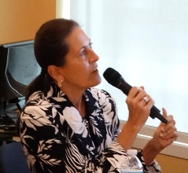

Dr. Cooper: The faculty member should guide delivery of the major learning outcomes by creating a learning community in the classroom that encourages all students' success. ALL student success. Work on their own development, #3.

Team 2

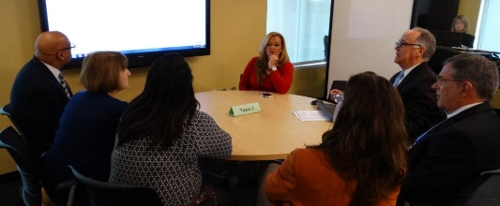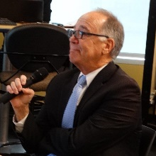

Dr. Duncan: We had lots of them. Clear expectations – it’s pretty simple. Standard syllabus, meaningful and timely feedback, #7.

Team 3

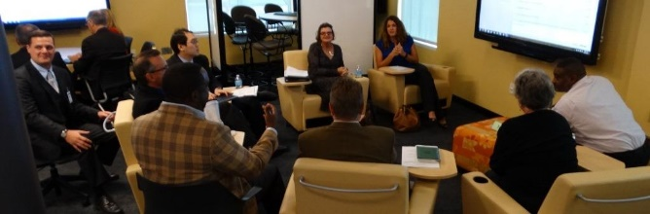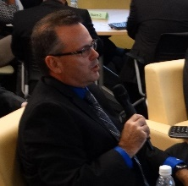

Dr. Coraggio: I think we had four. Quality, engaging and energetic professor #9. #10 – connecting learning outcomes with the program in which they are enrolled. Sometimes they think they are just getting busy work. They question what that task has got to do with their discipline.

Team 4

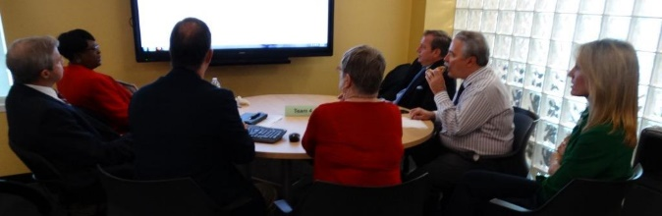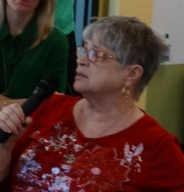

Dr. Setterlind: Out-of-classroom learning experiences. A lot of students are not taking advantage of the resources and tools – it’s the faculty’s responsibility to make them aware and the student’s responsibility to take advantage. Jonathan Steele put it well: be a guide on the side, not a sage on the stage.

11:00am –  11:30am | Learning Beyond the Classroom  This session will provide an overview of the growing list of opportunities to expand their learning beyond the classroom. Programs that nurture student participation in travel, internships, capstones, civic engagement, and academic competition will be reviewed and detailed. The impact and cost of these initiatives will be presented; additional reporting desired by the Board will be identified.  The outcome of this session will be to identify appropriate changes in policies, procedures, or allocation of resources needed to expand the college’s commitment to Learning Beyond the Classroom. | Topic 4 (30-min.):  - 5-min. “Just the Facts” Overview  - 20-min. Collaborative Discussion in teams  - 5-min. Team Reports:  Top 5 Considerations for 2016

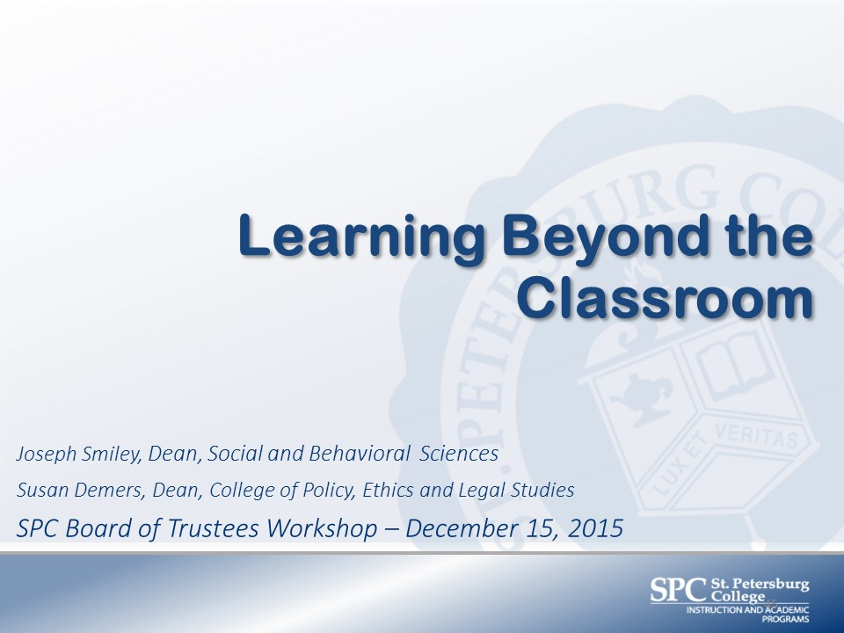

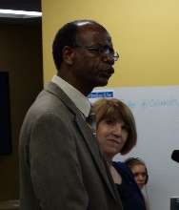
Dr. Joseph Smiley, Dean, Social & Behavioral Sciences: Learning Beyond the Classroom. Develop varied opportunities for engagement beyond the classroom. Civic engagement and global learning. Service learning projects, community service projects, community involvement projects and campus related activities. Dean Demers will make the connection between engagement and success rates.
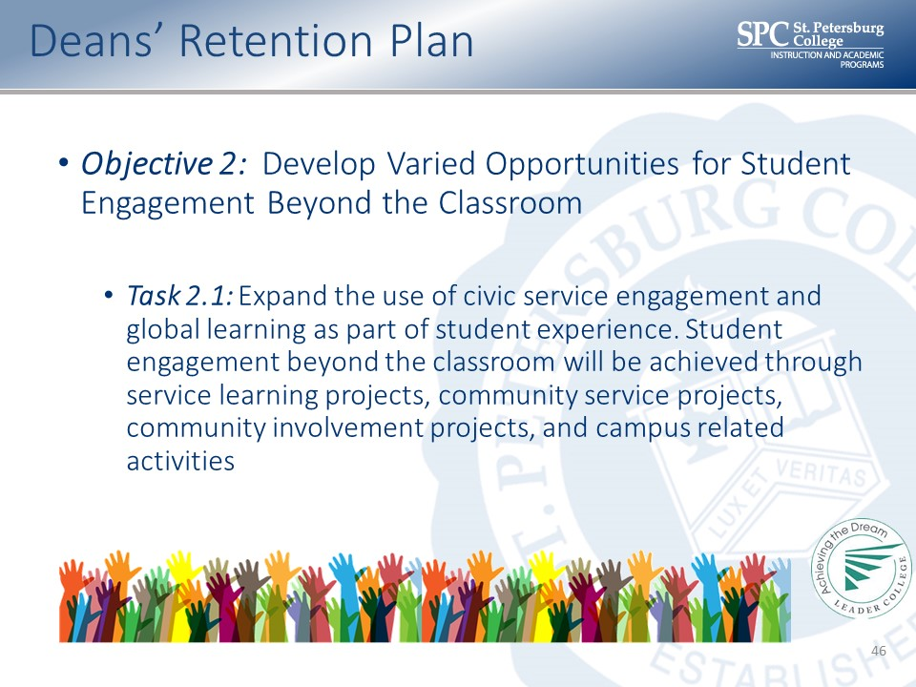
Dr. Demers, Dean, College of Policy Ethics and Legal Studies: Research shows that engagement and success rates are tied. Alumni surveys show that there are six undergraduate experiences. It’s people who graduate on time, with a manageable debt load, and they are pleased with their College Experience and in life. They want passionate teachers, mentors, people who treat us like people, etc. Two of them have to do with out-of-classroom experiences. We have data from our downtown campuses. Slide with participation and success rates.

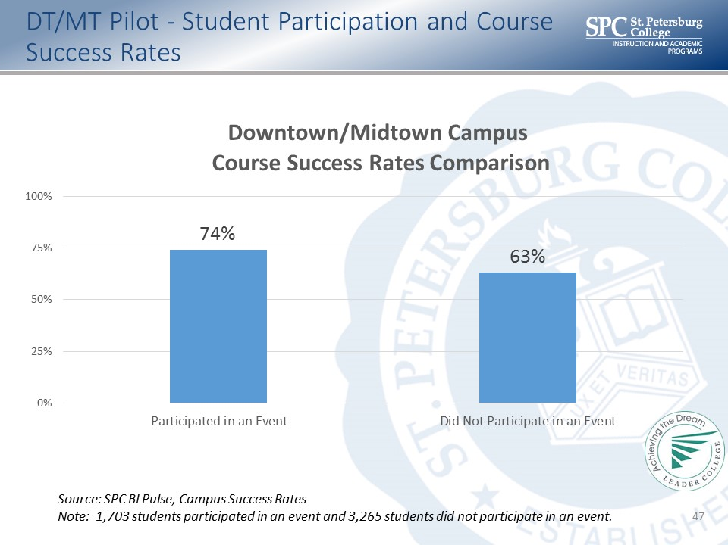

Dr. Smiley: We’ve been challenged to expand and enhance out-of-classroom activities in five categories. One is course-related: Model UN. More than 100 students participated. They work on real world experiences. Our students represented Macedonia. In Prague, they represented China. In the spring of 2016, they represent Luxembourg in NYC. The Ethics Bowl.

Second category: Study abroad. We are seeking to expand this. One example is our relationship with Ireland. Engaging in faculty exchange. There are two universities where faculty are exchanging. Some students are completing coursework in Ireland. Also cooperative research. We’d like to do more.

Third category: Community Service. Food Assistance Project – our downtown/midtown students offering support at the Free Clinic. Second example, over 30 students involved in providing mentorships at Melrose Elementary School in Pinellas Park. We hope to expand that.

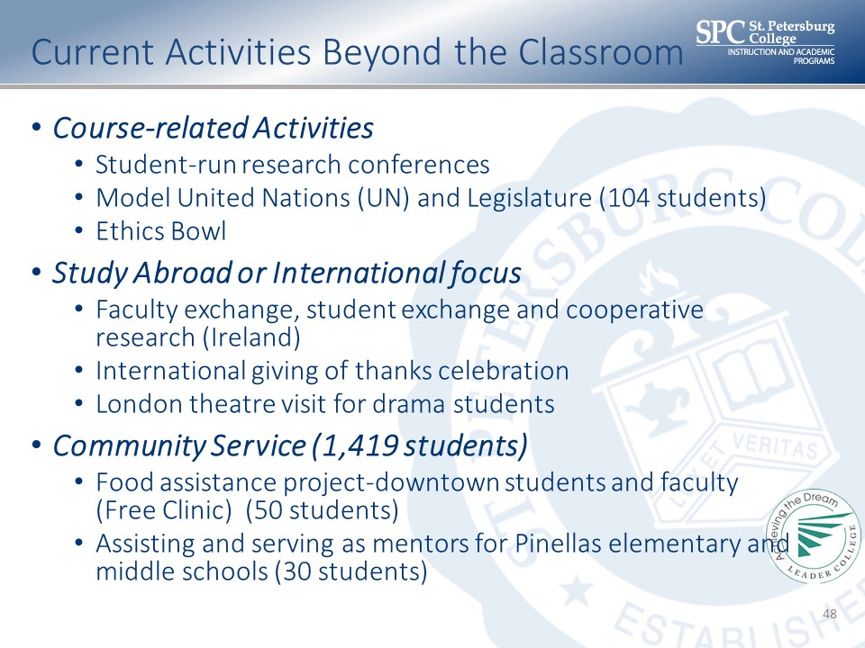
Fellowship and leadership: TurboVote. SPC was the #5 institute in the country to get registered voters. Art Experiences: Gallery shows, recitals and theatre performances.

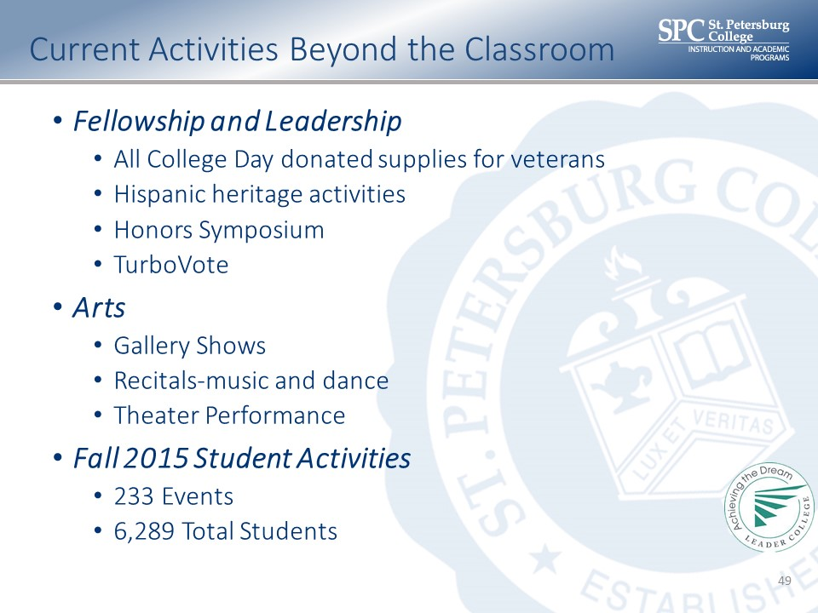
Dr. Demers: I would never dare to speak for Joe Smiley, but we thank you. We are here to ask for more. We want to expand civic engagement and service learning activities. We want to make our headcount bigger and better. We are rolling out the Center for Civic Learning and Community Engagement. We coordinated MLK Day of service across all campuses. Professor Newsome is wrangling all of that. We also want to add a co-curricular transcript. It would detail student activities and student achievements. There is a sample of one from the New York State system. This helps them with their transcripts, college applications and job applications.

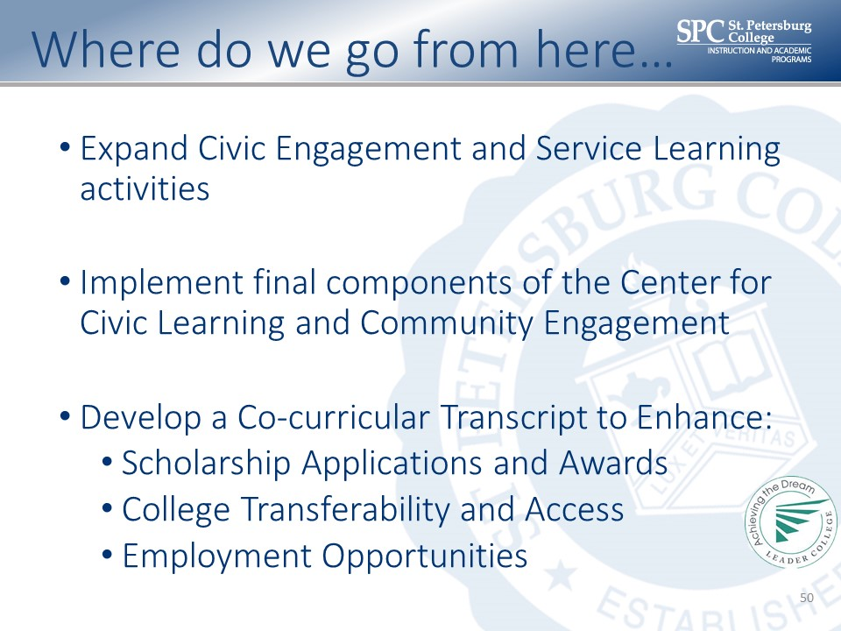
We have four questions for you to consider. You can see by my partner’s attitude that we are going to move forward aggressively unless you hold us back!

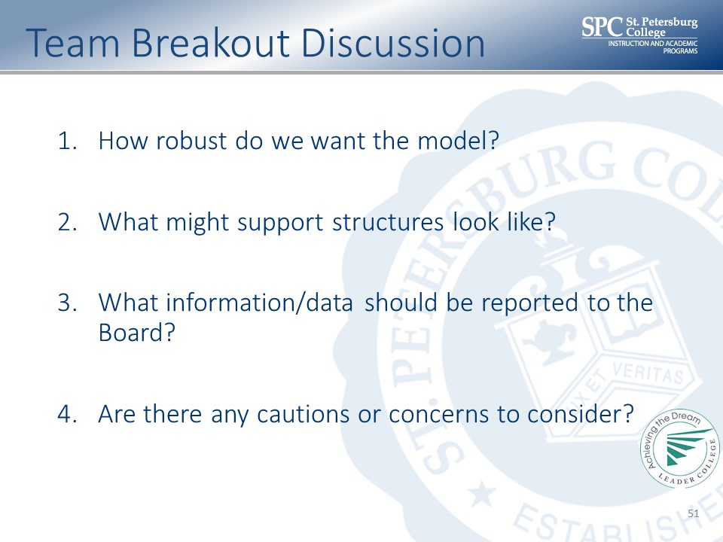
Andrea: We will meet you in the Forest Lab for our final discussion.

Team Assignments
Learning Beyond the Classroom
Team 1  - Brian Frank, College of Public Safety Administration  - Dale Oliver, Board of Trustees  - Greg Nenstiel, Dean College of Business  - Jesse Coraggio, VP Institutional Effectiveness and Academic Services  - Martha Campbell, Dean Communications  - Tonjua Williams, SVP Student Services  - Tyrone Clinton, Associate Provost | Team 3  - Deveron Gibbons, Board of Trustees  - Doug Duncan, SVP Business Services and Information Technology  - Jason Krupp, Director of Workforce Services  - Kimberly Hartman, Dean College of Education  - Richard Flora, Dean School of Veterinary Technology  - Scott Fronrath, Provost  - Susan Demers, Dean College of Policy Ethics and Legal Studies
Team 2  - Anne Cooper, SVP Instruction and Academic Programs  - Bridgette Bello, Board of Trustees  - Jamelle Conner, Provost  - Jimmy Chang, Dean Mathematics  - John Chapin, Dean Natural Science  - Jonathan Steele, Dean College of Humanities and Fine Arts  - Theresa Kontodiakos, Student Services Manager | Team 4  - Bill Law, President  - Brian Miles, Associate VP, Administrative Planning & Operations Support, Administration  - Joseph Smiley, Dean Social and Behavioral Sciences  - Marvin Bright, Provost  - Rebecca Ludwig, Dean College of Health Sciences  - Robert Fine, Board of Trustees  - Susan Baker, Dean College of Nursing

Learning Beyond the Classroom Team Reports

1. How robust do we want the model?
1. As large as reasonable based on the available resources
2. Continue to grow study abroad experiences
3. Current model in line with other college leaders in this area
4. Continue to grow our student clubs
5. Encourage student participation in professional organizations
6. Embed community engagement activities in programs and courses
7. Make it benchmark but make sure it does not impact your work/school balance.
8. Embed peer mentoring into the classroom experience.
9. Make civic engagement a sustainable hallmark of the College Experience

2. What might support structures look like?
1. Faculty leadership
2. Pre-established community partnerships
3. Student commitment to provide leadership after graduation
4. Co-curricular transcript allows students to see their engagement and accomplishments
5. Recognition of student participation ("learning beyond the classroom" certificate)
6. Connect data of service to students' transcripts

3. What information/data should be reported to the Board?
1. Participation numbers (link to student success)
2. Success of involvement
3. Impact it is having
4. Convert hours into dollars
5. Impact on the student
6. What is the value to the student, i.e. student success?
7. How marketing is letting community know what we are doing
8. Costs involved
9. Student testimonials

4. Are there any cautions or concerns to consider?
1. Explore other financial support for students (i.e. scholarships, grants)
2. Impact to the students, i.e. school-work balance, creating diverse service opportunities
3. Focus on both domestic and international opportunities

5. Top Considerations for "Learning Beyond the Classroom" in 2016
1. How do we balance community and external with the classroom experience (academics)?
2. Use pathways to identify courses which should include civic engagement or other opportunities
3. Civic engagement fair to let students know what is available
4. Students contribute ideas for service
5. Develop seamless connection between Student Services and Academic Programs.
6. How this helps us move the needle to student success
7. What is the impact on the College, i.e. costs involved, performance funding, mission to the College?
8. Every student should have the opportunity to engage in out of class activities tailored to each campus and academic program
9. Robust enough to support community needs
10. Make model a "benchmark"; make it a part of student expectations
11. College-wide marketing of available opportunities
12. Need financial support structure
13. Impact on the community-$$$$
14. Liability coverage (off-campus, international)

Team 1

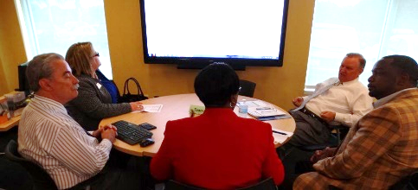

Theresa Kontodiakos, Student Services Manager: Balance the community with academics. Be sure that the civic component doesn’t take over the academics. Letting students know what opportunities are available at their campus for volunteers.

Team 2

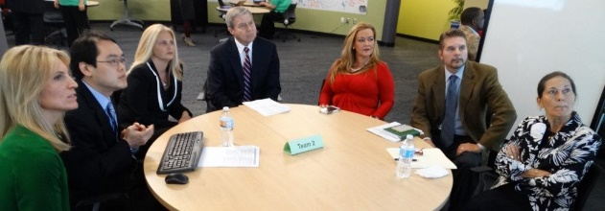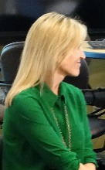

Dr. Tara Newsom, Associate Professor, Social & Behavioral Science: Students contribute ideas for service. So they are stakeholders. No matter how we go forward, we need to look at the impact to the college. Big investment in student services that we need to tie civic engagement to it.

Team 3

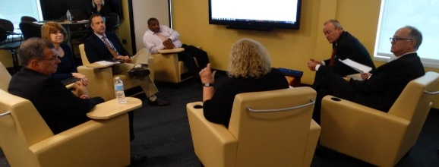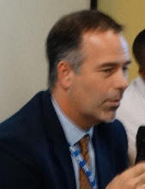
Dr. Jason Krupp, Director of Workforce Services: Every student should have the opportunity to engage in civic opportunities. Academic pathways to identify specific courses where they belong. Dr. Demers has offered up the ethics course for that.

Team 4

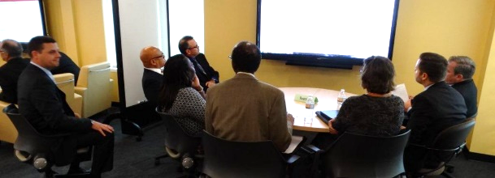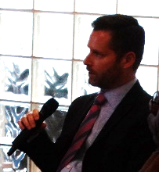

Brian Miles, Associate VP, Administrative Planning & Operations Support: We would like a program that supports student and community needs. A nationally benchmarked program that offers a certificate or recognition. Let students know the opportunities. Revenue resources and ROI to the community. Viability for international – though we recognize some of the pitfalls that might come from that. That didn’t come from me.

Andrea: Any others?

11:30am –  11:50am | Employee Development (Deferred)  This session will bring current the initiatives created in the past several years to enhance the growth, development, training, and preparedness of all employees at St. Petersburg College. Of particular note will be updates on the reclassification of the college’s advisors, the extensive redesign of the annual evaluation of Career Service  Employees, the progress that has occurred in the Faculty Portfolio Project and the overall expansion of training and support initiatives that has now been put in place.  The outcome of this session is to receive feedback from the Board on the fiduciary responsibility of the college to evaluate employees and to strengthen their relevant skills for the improvement of college operations. | Topic 5 (20-min.):  - 10-min. Overview of efforts underway and planned  - 10-min. BOT discussion

Dr. Law: The last area is one we can do in January. Let’s reassemble in the Tropics. Andrea’s team is putting together a handout for you as you walk out the door. Let’s look at the video from graduation.
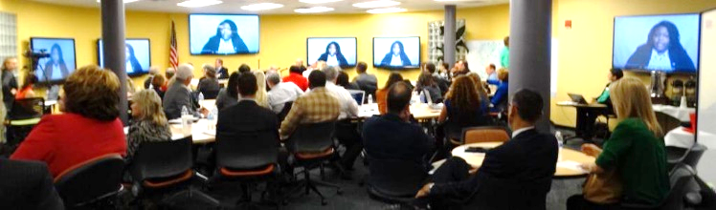
Participants watched a video of three recent graduates expressing what their attendance at St. Petersburg College has meant to them.

11:50am –  12:00pm | Wrap-Up and Next Steps | Dr. Law and the BOT will wrap-up by sharing highlights and next steps.

Dr. Law: That concludes all our presentations. We’ll defer the Employee Development section. We will follow up in the January meeting.

Chairman Oliver: Another great session to get us prepared for 2016. January 19th is our next meeting here at the EpiCenter. Happy New Year and a Merry Christmas.

Adjourned: 12:06

Dr. Law announced that Jeremy Peplow is leaving the college and he wished him well.

Artwork
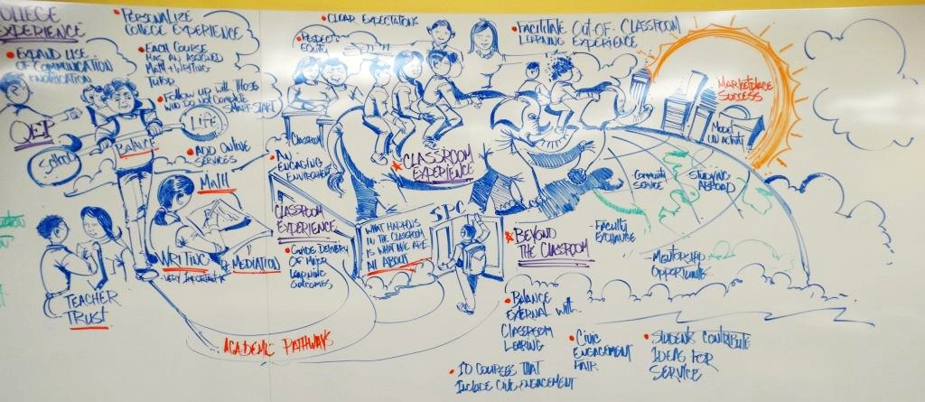

Additional Detail about 2015 Successes

Classroom Experience
- Proposing to revise policies to ensure timely completions of math courses within the math sequence
- Faculty completion of training modules as a result of developmental education reform
- Providing “low-stakes” assessments for Flex Placement students and to ensure correct “starting point” in their math pathway
- We use local industry coaches and mentors along with faculty to help students in our Business Plan course (Man 4801) refine their business plans, writing skills, and presentation skills.
- Increased use of adaptive learning allows students to focus solely on concepts they are learning for the first time as well as areas of reinforcement. They can skip what they already know.
- Total of 60 adaptive learning sections in developmental math through MAT 1033 in Fall 2015.
- Launch of online standard courses which were developed using Quality Matters standards.
- Personalized and adaptive learning with text-neutral course options in Music Theory classes, using multiple, free online resources
- A.S. program courses: Industry certificate preparation aligned and embedded in major learning outcomes.
- Test prep sessions are offered to prepare for certifications
- A textbook-free approach in Humanities, using a humanities resource website and free online resources and references.
- Incorporation digital design and fabrication through use of Adobe Illustrator and CNC Routers in Design II classes.
- In our senior Capstones (MAN 4934, MAN 4900, and MAN 4725), we use a nationally recognized Business Strategy Game (BSG) simulation. It simulates a real business environment where students have to make real time marketing, operations, human, and financial decisions using current financial data. Our average success rate in these three courses is 96%.

Learning Beyond the Classroom
- Tarpon springs Aquarium-10 students-self funded
- Multiple presentations involving the community—20 students, 30-40 community participants- services provided by campus.
- Genetically modified foods
- Birds of Prey
- Climate change
- Recycling
- Partnering with City of Clearwater for community clean-ups-self funded by students
- Field trips with Biotech students: 10-20 students-transportation costs only paid from lab fee budget:
- Research project at USF—diabetes cell therapies
- Research project at USF—Microbiomes
- Moffitt Cancer Vivarium and small animal imaging center tour
- DNA fingerprinting forensics workshop with NFSTC-Largo
- Student led Life Sciences Colloquium—student produced-200 participant. SGA funded-- $10,000
- Tri Beta National Biology Honor society field trips—costs various-15-20 students participants
- Field trip to TreeUmph—cost $50/student—self funded
- Field trip to look for fossils in the Hillsborough River—Led by Fossil Expeditions--$350—self funded
- Camping trip to Paynes Prairie and the Natural History Museum--$600—self funded
- Various undergrad research projects—funded by CETL and SPC foundation--$2,000-$4,000 per project
- Participation in the Florida Branch of the American Society for Microbiology, Florida Academy of Sciences statewide meetings. Poster presentations on research projects 20-30 students per year. Costs either self-funded or by CETL or Foundation grants
- Field Biology class visits a variety of state parks, the Florida Keys and do volunteer work with Tampa Bay Watch—15-20 students for each activity. Student funded or lab fee funded where appropriate.
- Students participate in the Society of Comparative and Integrative biology annual meeting—1-2 students. Funded by student government.
- A&P students producing video projects to help learning Human Anatomy and Physiology topics. 25-30 students produced 10 videos. Zero cost. Available on YouTube:
https://www.youtube.com/channel/UC8KIvw7_SBUmp7S1ingmcOA
- Seminole Environmental Club:
- Hosted 20120 documentary—Florida Wildlife Corridor. 15-20 students participated. No costs
- Presentations on bee-keeping involving the Pinellas Beekeepers Association. Participated in construction of an Apiary on the Seminole campus
- Field trip to Pinellas County Waste-to-Energy Plant—10 students. No costs.
- Wetlands Resources class did 4 field trips to a variety of wetlands in the area. 10-15 students participated. No cost.
- The Microbiology Student Research Association (MRSA!) Club:
- Meets weekly.5-15 students depending upon semester. Cost approx. $3,000 per semester. Funded by grants and some lab fee funds for basic supplies.
- Medical club at DT/MT:
- MOSI field trips—10-15 students. SGA funded
- Basic Life support & CPR Certification training—20 students—SGA funded
- Volunteering at Children’s Hospital Ronald MacDonald House—self funded—once a month—10-12 students
- Volunteering at St. Petersburg General Hospital—Guardian Angel Program—5 students, 4 hrs per week for 5 weeks thus far. Self-funded.
- A&P students at DT/MT attend cadaver workshops. 2 sessions per year. 20 students. No cost.
- 330 students actively participated in concerts, shows, recitals in the fall. There were 39 arts events of which 29 were dance, theater, music.
- 4 Professional development sessions for students pursuing careers in arts and entertainment. 37 students participated.
- Working Artist event (Palladium): networking between students, faculty, arts professionals, community leaders, and to provide timely, practical advice and techniques for success in arts careers. A total of 202 participated.
- Ceramics “Empty Bowls” project to engage ceramic art students and faculty with community needs through the St. Petersburg Free Clinic in a fund-raising effort sponsored by Highwater Clay. This will involve approximately 72 students.
- Linked-in Photo shoot provided by Photographic Technology interns: professional profile photos for SPC student employment search.
- SEmmy’s digital arts competition in the spring semester, open to SPC arts and Pinellas County Schools, with trophies to 18 category winners.
- MIRA music production competition: winning student music production is included on annual compilation CD.
- Charrette (art show) at Tarpon Campus: winners receive cash awards provided by student government. 45 students participated, 125 attended.
- 45 students in Design 2, Ceramics, and Printmaking presented their work in their respective Crossroads Gallery shows.
- Juried Art show at Clearwater Campus, cash awards for first, second, third place and “Juror’s purchase,” campus purchase of student art. 50 students participated.
- Ceramics pizza party at end of semester, where students make wood-fired pizza in a kiln. 80+ students participated.
- STEAM (Science, Technology, Engineering, Arts and Mathematics) students at DT led a mini-catapult competition which also involved members of the community as well as K-12 students.
- MGF 1107 students at the Clearwater campus visited the M.C. Escher exhibit at the Dali Museum to explore and research the use of mathematics in art and other related areas.
- Study Abroad trip to Greece involved a STA 2023 – Elementary Statistics class studying the subject, through data collection and research, in an international setting.

